Abstract

Purpose:
Public transportation is one of the main services offered by municipalities, sometimes with the help of private companies. From the end user point of view, the service is perceived favorably when it is reliable and on schedule, when it covers the entire city, possibly with direct and fast connections that fulfill the needs of the various users, and when it is easy to use, e.g., to buy valid tickets and access the service.
Thus, a key challenge is to address all above needs and to offer personalized services to citizens. This requires the new Information and Communication Technologies (ICT) to be massively exploited.
The goal of this project is to develop some of the core features of a system that can help a Metropolitan Transportation Authority (MTA) improve the service offered to citizens. The system is highly customizable with almost, nothing necessary hard coded.
Method Used (Technical Details):
The system has a centrally controlled web-application (J2EE based) that manages the database besides proving relevant information like any conventional website. Here every public station needs to set up a Bluetooth client, a small .jar application on their sites which detects the presence of valid customer from his pre-registered Bluetooth profile of his mobile. The client (at the station) uses the J2ME Bluetooth package highly customized to run with J2SE 6.
The client (running at every station) detects the presence of a Bluetooth user and sends its details i.e. the Bluetooth address to the web-application automatically for its authentication from the central database. Once, verified its details are stored in a data table and appropriate action is done, like deduction of balance after the journey or intimation of journey to user via SMS, etc. else an alarm is blown to mark the presence of an intruder.
Scope:
The System is developed specially for the metro service but could be very well used with other forms of public transport such as the bus service or the local tram service. Since the system is built on the open source technology available it’s highly cheap along with being reliable.

Usefulness:
The system is first of its kind exploiting the major developments in the Bluetooth Technology. Some of the key features are:-
- Allows a user to travel without getting into the hustle of buying tickets while waiting for turns in long queues.
- This keeps the user completely updated of the trips he makes using the system since he could check his travel log by logging into his account.
- Complete freedom to recharge his account online on the go or by the paying cash to the system manager available at every public station.
- Quick SMS service that gives an account update at the end of the journey.
- Keeps a user well-informed of any fault in any route and suggests alternate routes so that the user doesn’t land in any sort of inconvenience via a SMS.

- Introduction
1.1 Purpose
The purpose of this document is to outline the technical design of the Intelligent Transport System and provide an overview for the application implementation.
Its main purpose is to -
- Provide the link between the Functional Specification and the detailed Technical Design documents.
- Detail the functionality which will be provided by each component or group of components and show how the various components interact in the design.
- Provide a basis for the Intelligent Transport System’s detailed design and development.
As is true with any high level design, this document will be updated and refined based on changing requirements.

1.2 Document Organization
This document is organized into the following sections:
Introduction | Provides information related to this document (e.g. purpose, term definitions etc.)
Design Overview | Describes the approach, architectural goals and constraints, guiding principles, Java Design patterns used in design and development.
Topology Diagram | Describes the various system components and the integration between them.
Application Architecture | Describe the application architecture in terms of different layers of application. Description of the presentation layer, business layer, control layer and their relationship to each other.
Database Architecture | Describes the overall Data model for the INTELLIGENT TRANSPORT SYSTEM.
Assumptions and Constrains | Details various assumptions made during design and development of the INTELLIGENT TRANSPORT SYSTEM.
Appendix A | Describes Acronyms, Abbreviations, Terms and Definitions
Appendix B | Lists all products and tools used in design and development
Appendix C | Lists all the configuration files used in implementation

1.3 Audience
The intended audiences for this document are the project development teams, technical architects, database designers, testers and vendors.

1.4 Acronyms, Abbreviations, Terms and Definitions
Please refer to Appendix A for a list of all acronyms and abbreviations.

- Design Overview
2.1 Architectural Goals and Constraints
The overall architecture goals of the system is to provide a highly available and scalable system that can help a Metropolitan Transportation Authority improve the services offered to citizens and improve efficiency of public transportation and bring in massive use of new Information and Communication Technologies.
The core features of the system are:-
- Allow a citizen to register into the system and pre-pay for a certain number of trips;
- Recognize when a registered citizen gets on a bus and determine the journey he/she performs, calculating the fare he/she has to pay, and detracting it from his/hers credit.
- When the citizen’s credit is finished, allow him/her certain recharge options.
- Provide registered citizens with information about changes in the lines they use most frequently.
A key Architectural goal is to leverage industry best practices for designing and developing a scalable, enterprise-wide J2EE application. To meet this goal, the design of the INTELLIGENT TRANSPORT SYSTEM is based on core J2EE patterns as well as the industry standard development guidelines for building the Online Screening Tool.

2.2 Guiding Principles
Guiding principles provide a foundation upon which to develop the target architecture for the INTELLIGENT TRANSPORT SYSTEM, in part by setting the standards and measures that the system must satisfy. These in turn drive design principles that can be used to validate the design and ensure that it is aligned with overall Architecture, Design Principles and Standards.
Some of the guiding principles that will be followed during the INTELLIGENT TRANSPORT SYSTEM design and development are outlined below.

2.2.1 Scalable
Scalability is the ability of the platform to scale both up and down to support varying numbers of users or transaction volumes. The application should be able to scale horizontally (by adding more servers) or vertically (by increasing hardware capacity or software efficiency).

2.2.2 Flexible
Flexibility is the ability of the application to adapt and evolve to accommodate new requirements without affecting the existing operations. This relies on a modular architecture, which isolates the complexity of integration, presentation, and business logic from each other in order to allow for the easy integration of new technologies and processes within the application.

2.2.3 Standards-Based
Portal services will comply with established industry standards. The standards-compliance will not only apply to application development but also to design, platform/infrastructure and other parts of the Intelligent Transport System. Examples of standards include HTML, XML, J2EE, and JSP.

2.3 Design Patterns
Design patterns are elements of reusable object oriented software. A design pattern catalog is a repository of design patterns. Use of such patterns makes the design of an application transparent. These patterns have been used successfully by developers in their respective fields, and therefore, the pros and cons of the pattern (as well as implementation issues) are known beforehand. All design patterns are reusable and can be adapted to particular contexts.
Some of the design patterns which will be used in the design and development of the Intelligent Transport System are -
- Front Controller
- Model View Control

2.3.1 Front Controller
The Front Controller pattern helps to implement a centralized entry point that controls and manages user (screen) request handling. The controller manages the handling of the request, including invoking security services such as authentication and authorization, delegating business processing, managing the choice of an appropriate view, handling errors, and managing the selection of content creation strategies.

2.3.2 Model View Control
Here the user interacts with the View that is the JSP and the HTML pages. The Controller is the Servlets that takes user input from the request and figures out what it means to the model. The Model holds the real business logic and the state. It is the only part of the system that talks to the database. It knows the rules for getting and updating the state.

2.4 Design Principles
Best practices and design principles will be applied in –
- Presentation Services to individual desktops should be uncoupled -
- Presentation services are delivered to a web browser rather than to custom client software. A range of modern browsers that support HTML, DHTML, and XML are required.
- A common look and feel for Intelligent Transport System web application.
- Client side JavaScript should be used for validating user input and prevent round trips between the browser and the server.
- The Online application user interface is designed in such a way that common user interface functionality will be implemented in a similar manner across the board.
Examples of this include –
  - A consistent way of capturing customer and station-manager inputs.
  - A uniform way of displaying informational and error messages to the users.
  - A uniform way of displaying required and optional fields in the screens.

- HARDWARE & SOFTWARE REQUREMENT

For software development very first and essential requirement is the availability of software and hardware. ‘Intelligent Transport System’ requires the following software and hardware for it successful implementation.
  - Software Requirement :
Server Side (Recommended)
Operating System: ANY
Scripting Language: JSP
IDE: Ecplise
Front- End: Java and JSP
Back-End: MySql
Mark-up Language: HTML

  - Hardware Requirement :
Client Side (Recommended)
Processor: Pentium IV or above
Ram: 512 MB
Hard Disk: 10 GB
Mobile Phone: Bluetooth Enabled with SMS
Server Side (Minimum)
Processor: Pentium IV or above
Ram: 1 GB
Hard disk: 10 GB

- Topology Diagram
Web Server

Data exchange over HTTP b/w the web-server & station machine.
Database
Upper Tier


Station Machine
Station Machine
Station Machine

Data exchange over Bluetooth b/w the station machine & cell phone.

Middle Tier


Cell phones
Cell phones
Cell phones
Lower Tier

  - Interaction of various components:
- Web Server – Web server is responsible for serving web pages, mostly HTML pages, via the HTTP protocol to clients. The Web server sends out web pages in response to requests from browsers. A page request is generated when a client clicks a link on a web page in the browser.
- Application Server – Application server hosts the Intelligent Transport application and hosts the business logic and the business model classes of applications. It serves requests for dynamic HTTP web pages from Web servers.
- Database – BueTransport database stores the customer accounts, travel logs and registered users log in relational format.
- HTTP - Hyper Text Transport Protocol is the communication protocol used to connect to servers on the World Wide Web. The primary function of HTTP is to establish a connection with a Web server and transmit HTML pages to the user's browser. Since this is a stateless protocol, session needs to be established for identifying requests from a single machine.
- JDBC – Java Database Connectivity is an application program interface (API) specification for connecting programs written in Java to the data in popular databases. The application program interface lets you encode access request statements in structured query language (SQL) that are then passed to the program that manages the database. It returns the results through a similar interface.
- Bluetooth - Bluetooth is a proprietary open wireless technology standard for exchanging data over short distances (using short wavelength radio transmissions) from fixed and mobile devices, creating personal area networks (PANs) with high levels of security.

- Data Flow Diagrams

The dataflow diagrams show the graphical representation of the flow of data in and out of the system. At the first level the whole system is viewed as a single process with various entities interacting with it.

The processing is detailed more and more as we increase the level of study. Here the whole process of Intelligent Transport System is represented in three levels. The arrows mark the flow of data, the rectangular boxes the entities and the parallel lines represent the data stores such as databases or flat files.

  - Context Level Diagram:

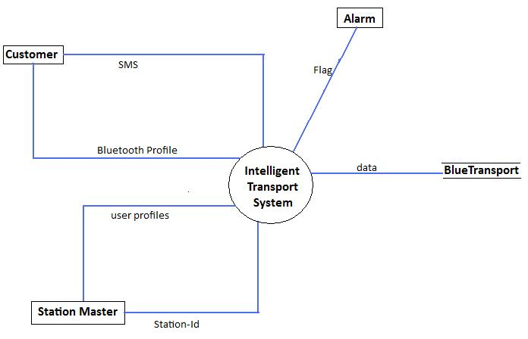

  - Level 1 diagram:
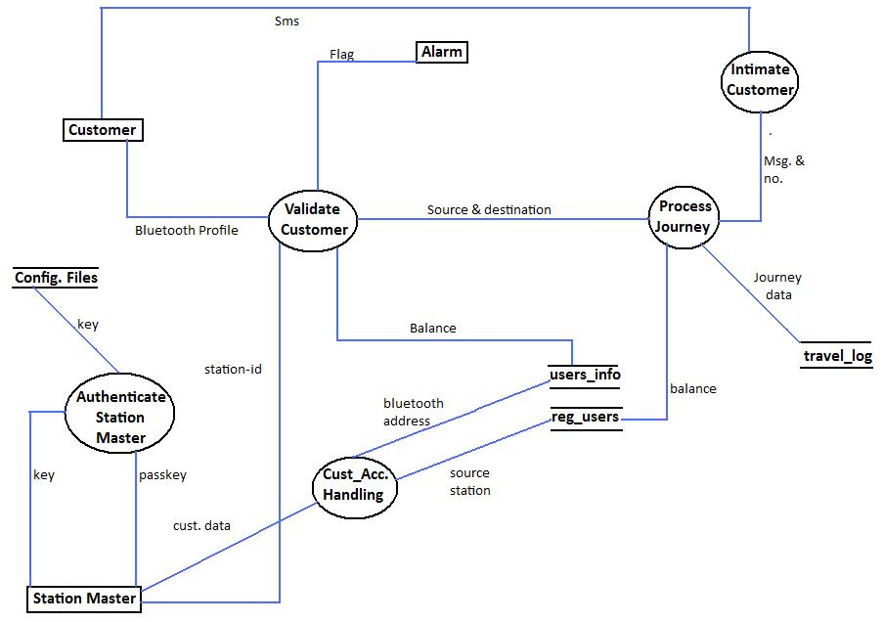

3.3 Level 2 Diagram:
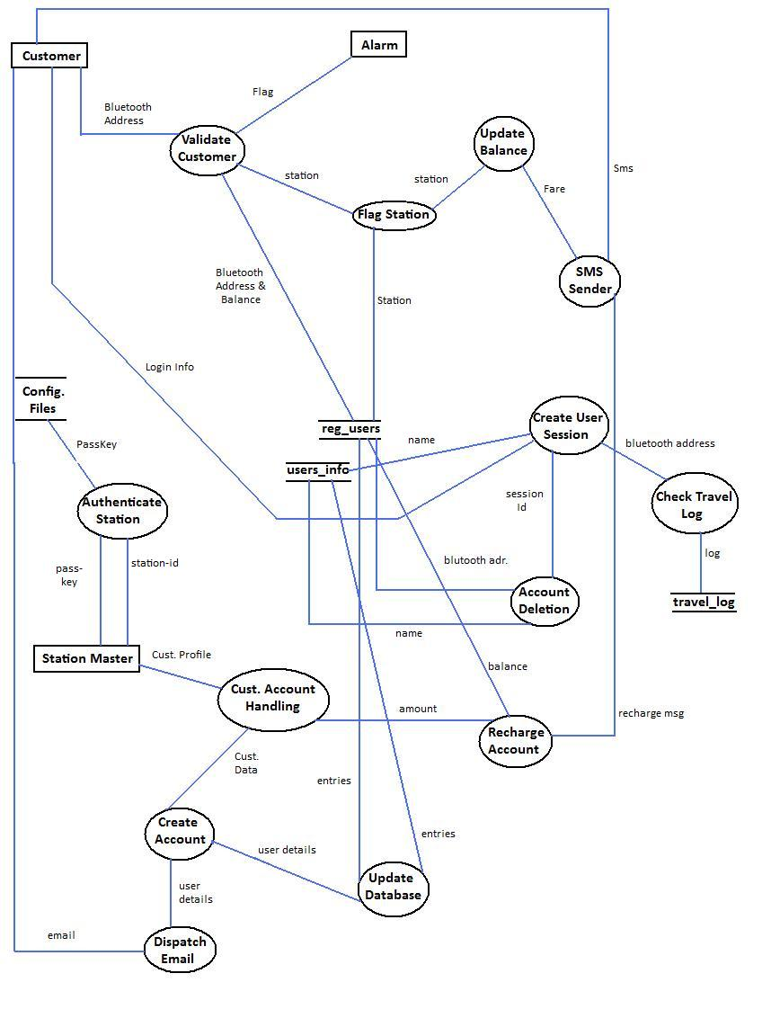

- Package Structure View
Package structure depicts the various packages used in the Intelligent Transport System and relationship among them. The package structure of the web application is based on the Model-View-Control design pattern. Here the user interacts with the View that is the JSP and the HTML pages.
The Controller is the Servlets that takes user input from the request and figures out what it means to the model. The Model holds the real business logic and the state. It is the only part of the system that talks to the database. It knows the rules for getting and updating the state.
Servlets

Control

<%
JSP
%>
class Foo{
viod bar(){
}
}

View
Model

DB

MVC in the Web-Architecture

com
control

BlueTransportContextListener.java
CustomerCreater.java
CustomerVerifier.java
LoginUser.java
LogOut.java
Recharge.java
StationAuthentication.java
TravelLogFetcher.java

model
AccountEmail.java
CreateDataStorage.java
DataBaseWorker.java
SmsPost.java
UserInfo.java

View
Account.jsp
AddCustomer.jsp
Recharge.jsp
Login.jsp

4.1 A Brief description of the various classes (of the web-application) in the Packages:-

- BlueTransportContextListener:
This class makes up the BlueTransport database and the associated tables when the web – application is first loaded up. This class waits for the servlet context to be initialized and when it does this is notified and this then makes up the database.
- CustomerCreater:
This class is used to create a new Customer profile into the database. This takes up data forwarded from the AddCustomer that is in authority of the station – manager.
- CustomerVerifier:
This handles up the issue of verifying that a customer is a valid user. This takes in the Bluetooth address sent out by the station-machine and responds to whether the customer is fake or if she/he doesn’t have the sufficient balance to start a journey.
- LoginUser:
This class maintains the mechanism to create the session between a customer and the web application. The user is usually authenticated against his username and password that serves as his login information, which is later checked against the database.
- LogOut:
This class has the mere functionality to destroy a session. This is done by the customer at will by clicking the Log out button/link.
- Recharge:
This is used by the station – manager to recharge the balance of a customer by using either his email, Bluetooth-address or cell phone’s IMEI no against the cash given.
- StationAuthentication:
This class is used to authenticate the station-machine and authorize it later. This processes the passkey entered by the station-manager and returns a station-id.
- TravelLogFetcher:
This class is solely designed to cater to the needs of the customer. This helps a logged in customer to fetch his travel log from the database as per the specified dates.

- AccountEmail:
This encapsulates the core methods to send out the email to a registered user. This works out on the SSL for username and password encryption over the internet.
- CreateDataStorage:
This is the core class that creates the database structure for the Intelligent Transport System. Its methods are fired from the BlueTransportContextListener upon context initialization.
- DatabaseWorker:
This class aims to work at updating the database and fetching the necessary data out of it by firing sql queries over the database using the JDBC.
- SmsPost:
This works out the issues of sending out the SMS to the customer by connecting to the sms-gateway.
- UserInfo:
This manages up the new customer profile and then subsequently uses the DatabaseWorker to add up that profile to the specified tables in the database.

4.2 A Brief description of the various classes (of the Bluetooth desktop-application):-
- Login:
This works on the issue of logging up a genuine station-manager over the station-machine. This authenticates the station-manager and authorizes the station-machine. This takes place by checking a passkey of the station-manager which is taken as a input using a GUI.
- ModeLauncher:
This class is built up to support the GUI of the desktop application running on the station-machine. This support two modes the automatic and the manual mode. In the automatic mode, the machine automatically checks for new Bluetooth cell phones in range at predefined intervals of time as against the manual one, where the station-manager has to push a button to check for new Bluetooth cell phones in range whenever he wishes to. This also maintains the log of the cheaters and the low balance profiles in a file named Tracker.log.
- PlayWav:
This class holds up the mechanism to play the alarm buzzer in case an intruder has been found.
- RemoteDeviceDiscovery:
This class encapsulates the mechanism to find out the Bluetooth cell phones in the vicinity, capture their profiles in a list and use it for further processing. This uses some core J2ME classes to communicate over the Bluetooth protocol.

- Application Implementation

The Intelligent Transport System would be deployed as a WAR on the server. Its counterpart BlueTracker would be deployed as a JAR with blueclove.jar in the classpath on each station-machine.
6.1 Directory Structure:
JAR | JAR: Java Libraries and classes are bundled as JAR (Java Archive) with a .jar extension.
WAR | J2EE Web applications are packaged as WAR (Web Archive) with a .war extension.

Diagrammatic layout of the Intelligent Transport System on the main server deployment structure is shown below –
Web Archive
META-INF
manifest.mf

WEB-INF
classes

Images
lib

JSP
web.xml

HTML

- RELATIONAL DATABASE MANAGEMENT DESIGN

The RDBMS used for designing this software is MySql. The main database is the bluetransport that contains 3 tables.

Tables in bluetransport
registered_users
travelers_log
users_info

7.1 Description of registered_users:-

Field | Type | Null | Key | Default | Description
BLUETOOTH_ADR | varchar(13) | NO | PRI | NULL | Bluetooth Address of mobile phone
NAME | varchar(40) | YES |  | NULL | Name of client
EMEI | varchar(15) | YES |  | NULL | Imei of mobile of client
DOB | varchar(20) | YES |  | NULL | Date of Birth of client
CELL_NO | varchar(20) | YES |  | NULL | Mobile no. of client
SOURCE_ID | varchar(20) | YES |  | NULL | Origin station of journey
BALANCE | int(10) | YES |  | NULL | Balance of account of client

7.2 Description of users_info:-

Field | Type | Null | Key | Default | Description
BLUETOOTH_ADR | varchar(13) | NO | PRI | NULL | Bluetooth Address of mobile phone
USERNAME | varchar(40) | YES |  | NULL | Username of the client
PASSWORD | varchar(30) | YES |  | NULL | Password of the client
NAME | varchar(30) | YES |  | NULL | Name of the client
EMAIL_ID | varchar(40) | YES |  | NULL | Email of client
GENDER | varchar(6) | YES |  | NULL | Sex of client
STREET | varchar(30) | YES |  | NULL | Address of client
CITY | varchar(20) | YES |  | NULL | Do
STATE | varchar(20) | YES |  | NULL | Do
COUNTRY | varchar(15) | YES |  | NULL | Do
ZIP | varchar(10) | YES |  | NULL | Do

7.3 Description of Travelers_log:-

Field | Type | Null | Default | Description
BLUETOOTH_ADR | varchar(15) | NO | NULL | Bluetooth Address of mobile phone
SOURCE | varchar(15) | YES | NULL | Name of the origin station of Journey
DESTINATION | varchar(15) | YES | NULL | Name of the Destination Station
DATE_VALUE | date | YES | NULL | Date of Journey
FARE | int(20) | YES | NULL | Fare of Journey

The account information of a customer in registered_user and the travel log would be used by the customer, whereas the users_info and the registered_user would be used by the station manager. The Intelligent Transport System Records will be generated off the BlueTransport database using SQL queries using JDBC, as illustrated in the diagram below :-

MySql 5.1

Online Intelligent Transport System
queries & data

Records

Customer Account Information
Customer Travel Log

  - ER Diagram
City

Namee
Address
Street
State
Country
ZIP
Name/Id
Account
Password
Balance
D.O.B.
Travels b/w
Passkey
Bluetooth_Adr
Bluetooth_adr
Source
CheckLog
Destination
Date
Fare
User
Registered User
Station
Mobile
Travel_Log
Username
Authenticate
Cell No.
IMEI No.

- User Interface
  - Station Machine User Interface
The Station Manager uses the BlueTracker.jar for interacting with the Intelligent Transport Main Station and with the Bluetooth profiles of the customers at the station.

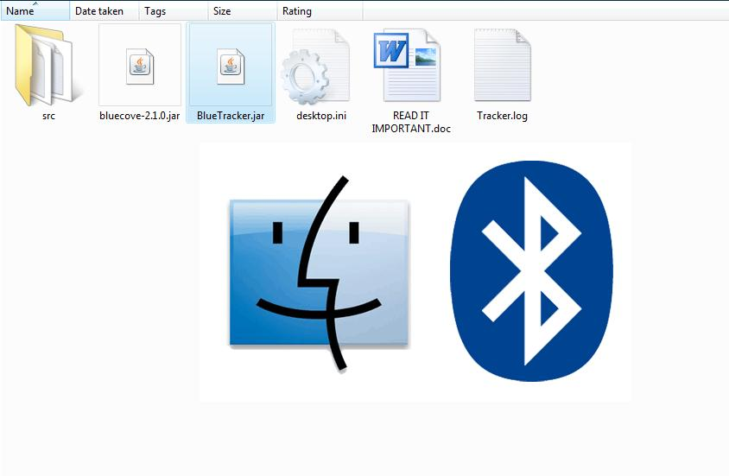
This Splash-screen image marks the start of the desktop application named BlueTracker.jar.

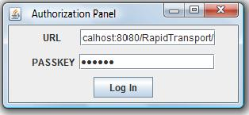
The URL of the ITS web-application
A secret passkey that authenticates the station manager

Successful authentication
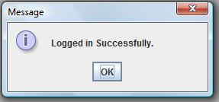

Invalid Passkey or URL entered
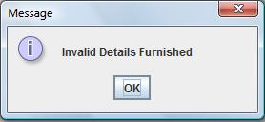

Selecting Operation Mode…. Default being Manual
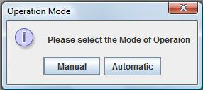

Search Pulse traces out the Bluetooth profiles active over a specific range.

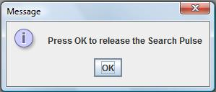

The time span required to release the search pulse in AUTOMATIC MODE.

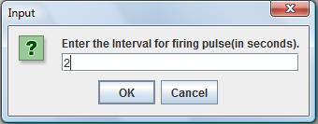

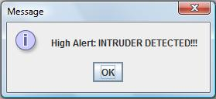
Intruder alert message along with the buzzer.

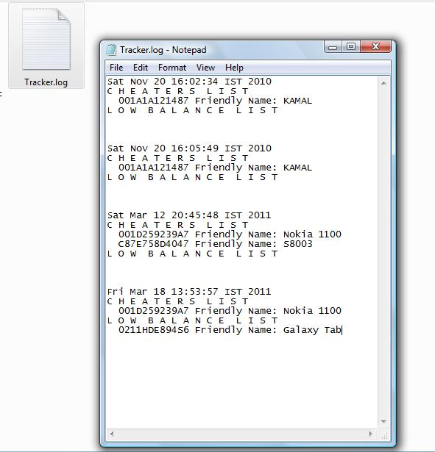
Tracker Log of the Intruders

The user interface of the web-application that is to be used both by the station-manger and the customer

8.2 The Station-manager interface to the web-application:
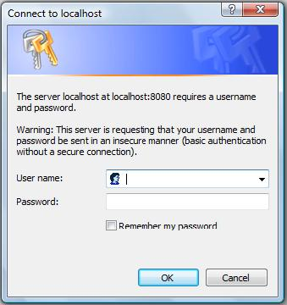

The Basic Authentication method used to authenticate the station-manager.

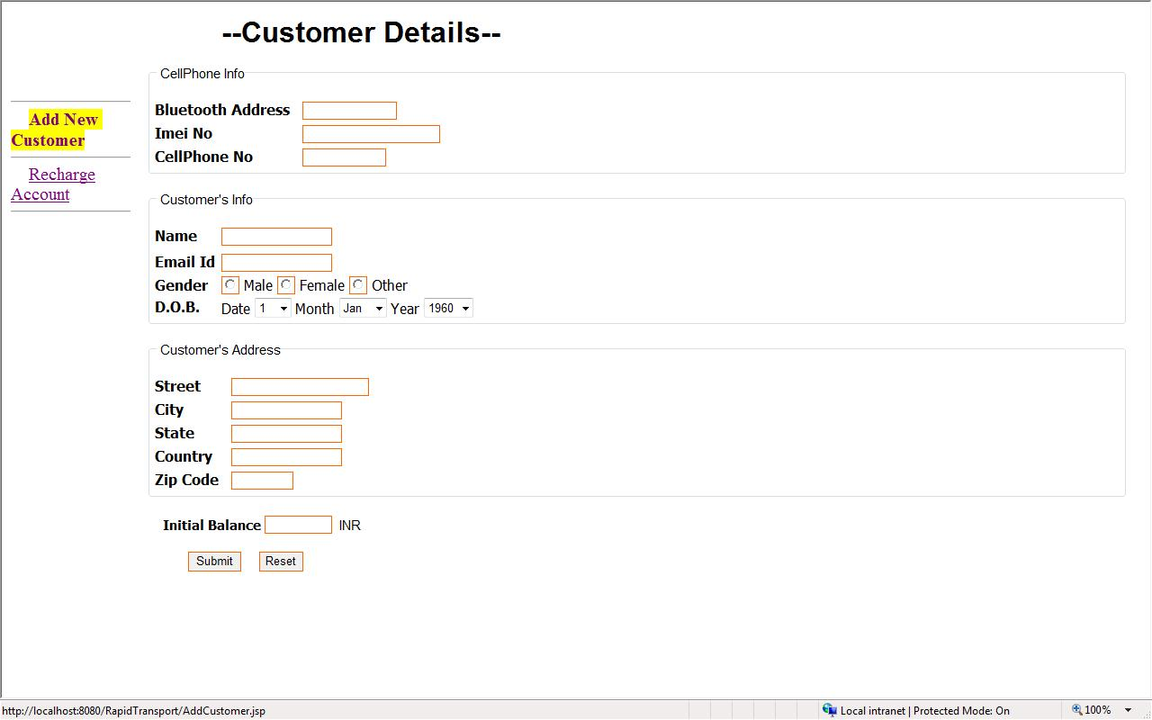

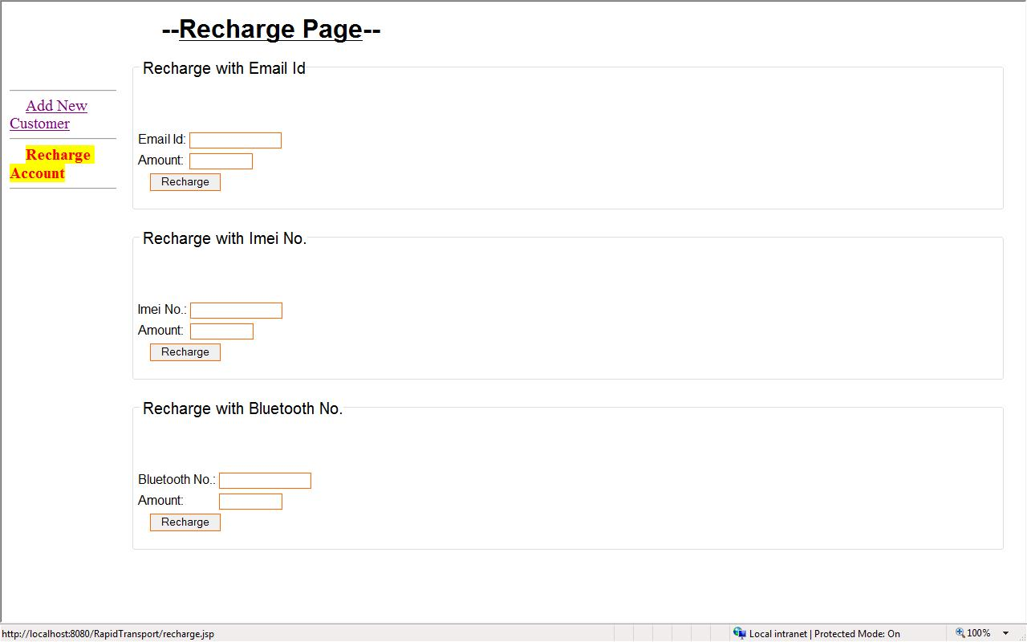

8.3 The user interface used by the customer to gather information and access his/her account:-
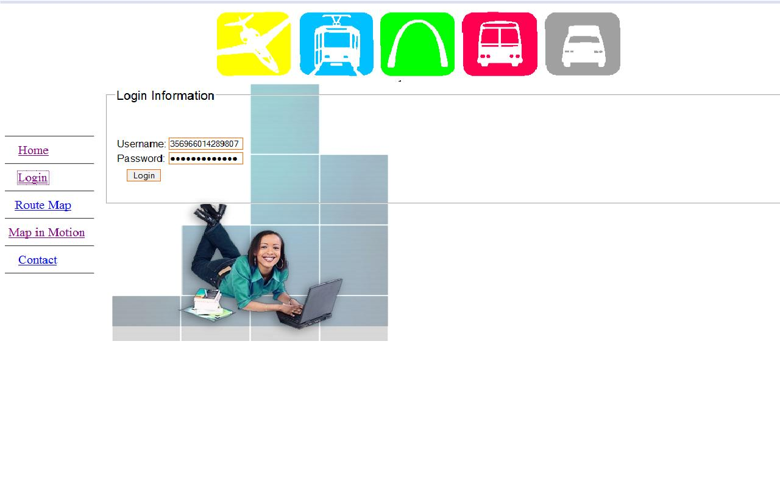
The Username and Password of a customer.

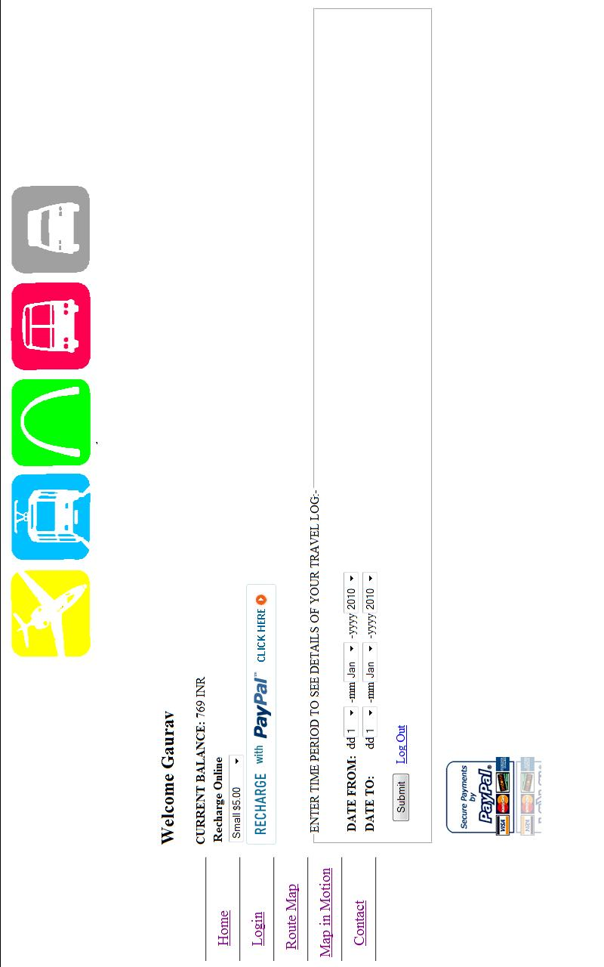
The Online Recharge Option for the registered user using APIs of PayPal™.

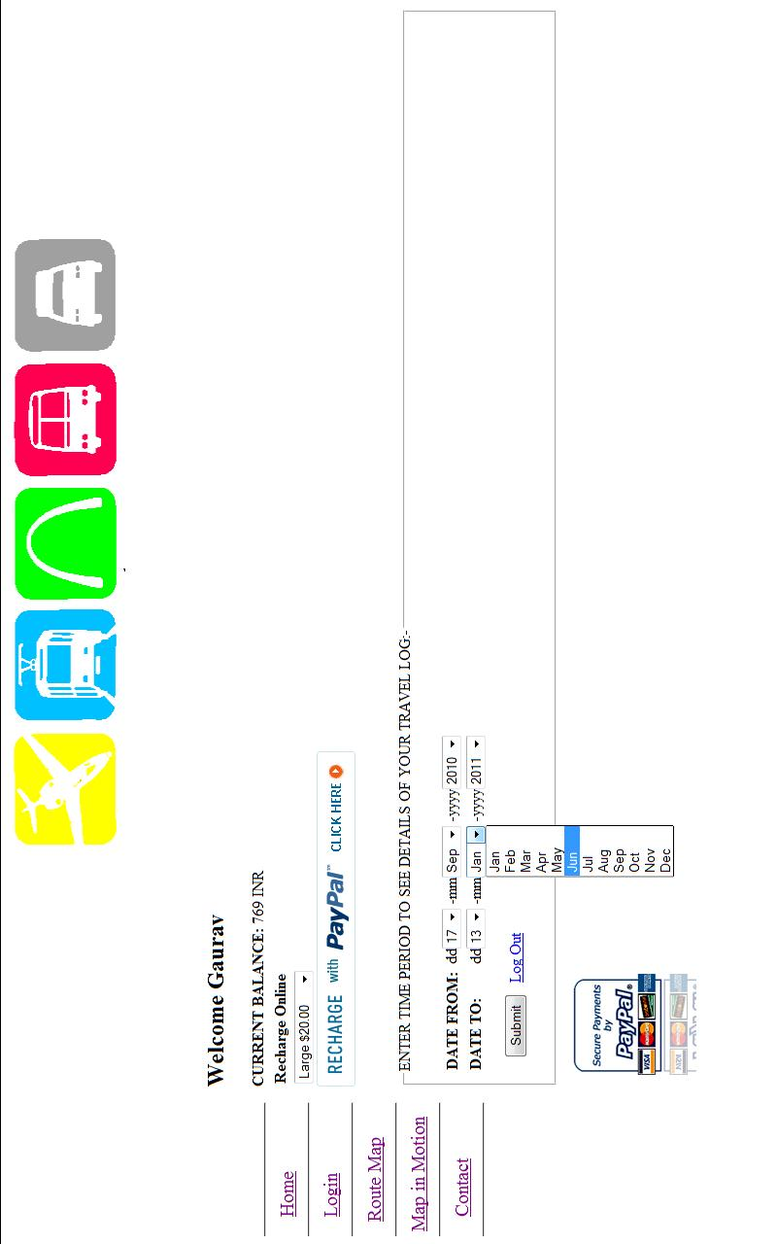
Checking of Travel Log by the customer within a specific time span.

The Internet Payment Gateway of PayPal™ for acception the online Recharge.
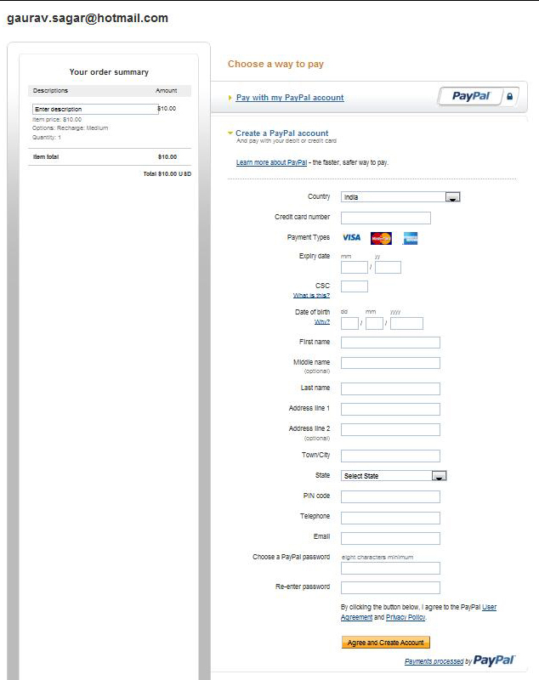

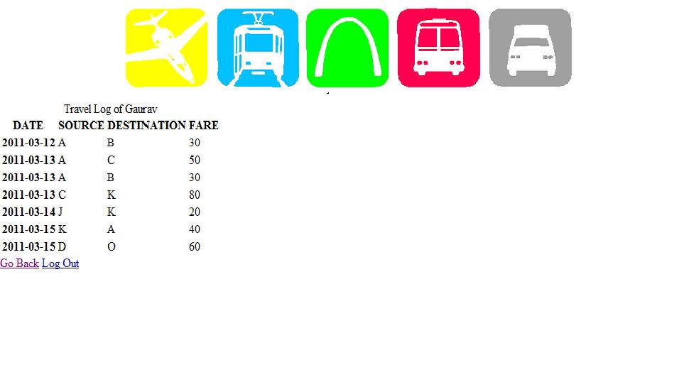

Travel Log of the Customer as per the previously specified dates.

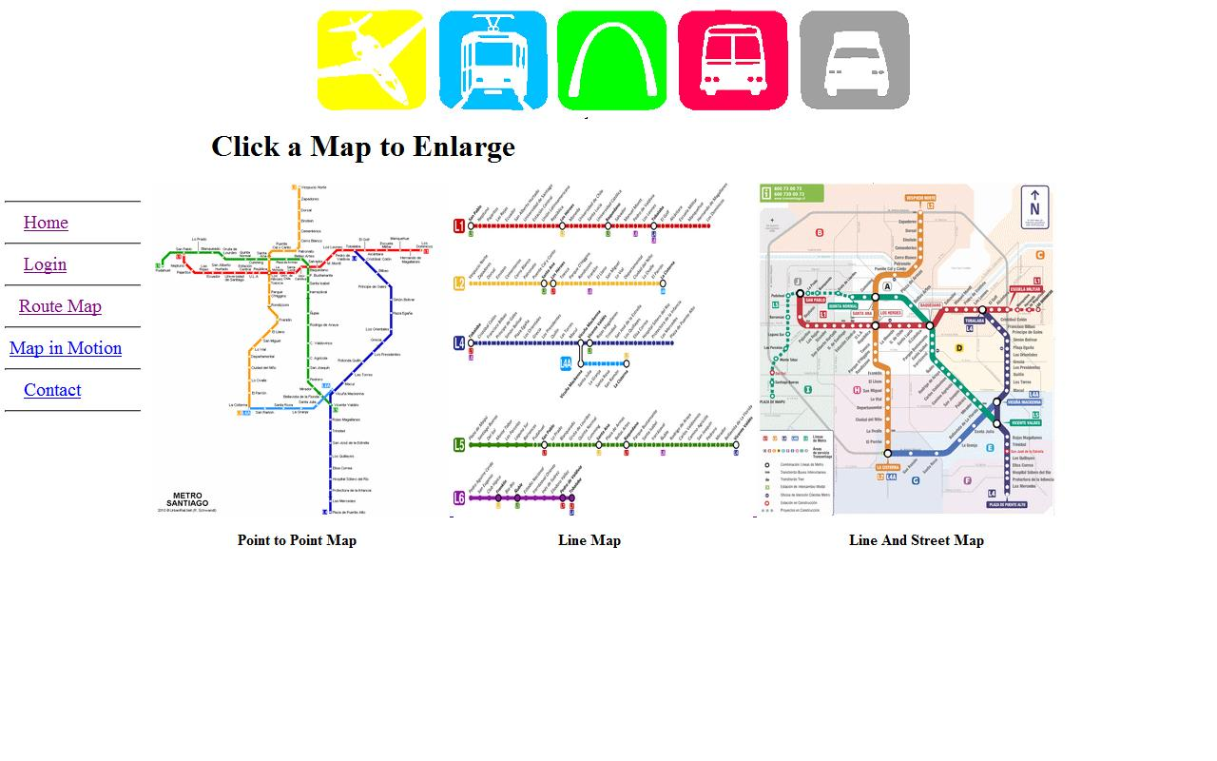
The detailed maps of the entire route of the system, namely:-
Point
Line
Street

9 TESTING
9.1 Integration and Test stage:
During the integration and test stage, the software artifacts, online help, and test data are migrated from the development environment to a separate test environment. At this point, all test cases are run to verify the correctness and completeness of the software. Successful execution of the test suite confirms a robust and complete migration capability. During this stage, reference data is finalized for production use and production users are identified and linked to their appropriate roles. The final reference data and production user list are compiled into the Production Initiation Plan.
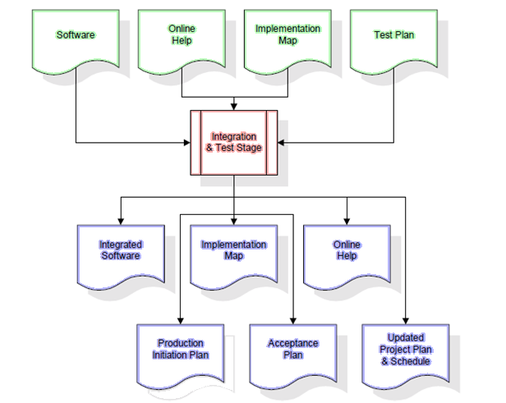
The outputs of the integration and test stage include an integrated set of software, an online help system, an implementation map, a production initiation plan that describes reference data and production users, an acceptance plan which contains the final suite of test cases, and an updated project plan.
9.1.1 Testing:
The process of running a system with the intent of finding an error. Testing is defined as the process in which defects are identified, isolated, subjected for rectification and ensured that product is defect free in order to Quality is defined as justification of the requirements Defect is nothing but deviation from the requirements Defect is nothing but bug.
Testing --- The presence of bugs
Testing can demonstrate the presence of bugs, but not their absence Debugging and Testing are not the same thing!
Testing is a systematic attempt to break a program or the AUTO Debugging is the art or method of uncovering why the script /program did not execute properly.
9.1.2 Testing Methodologies:
Black box Testing: is the testing process in which tester can perform testing on an application without having any internal structural knowledge of application.
Usually Test Engineers are involved in the black box testing.
White box Testing: is the testing process in which tester can perform testing on an application with having internal structural knowledge. Usually The Developers are involved in white box testing.
9.1.3 Test Planning:
1. Test Plan is defined as a strategic document which describes the procedure how to perform various testing on the total application in the most efficient way.
2. This document involves the scope of testing,
3. Objective of testing,
4. Areas that need to be tested,
5. Areas that should not be tested,
6. Scheduling Resource Planning,
7. Areas to be automated, various testing tools
9.1.4 Result Analysis:
1. Expected Value: is nothing but expected behavior of application.
2. Actual value: is nothing but actual behavior of Application
Bug Tracing: Collect all the failed cases, prepare documents.
Reporting: Prepare document (status of the application)

9.1.5 TCD (Test Case Document):
Test Case Document Contains
Test Scope (or) Test objective
Test Scenario
Test Procedure
Test case
9.2 Functional Testing:
The functions that a system, subsystem or component are to perform may be described in work products such as a requirements specification, use cases, or a functional specification, or they may be undocumented. The functions are “what” the system does.
A type of functional testing, security testing, investigates the functions (e.g. a firewall) relating to detection of threats, such as viruses, from malicious outsiders. Another type of functional testing, interoperability testing, evaluates the capability of the software product to interact with one or more specified components or systems.

9.3 Structural Testing:
Structural testing is white box testing, not black box testing, since black boxes are considered opaque and do not permit visibility into the code. Structural testing is also known as clear box testing, also known as glass box testing. Structural testing is a way to test software with knowledge of the internal workings of the code being tested. Structural testing may be performed at all test levels. Structural techniques are best used after specification-based techniques, in order to help measure the thoroughness of testing through assessment of coverage of a type of structure.
Structural testing approaches can also be applied at system, system integration or acceptance testing levels (e.g. to business models or menu structures).
9.4 Stress Testing:
In software testing, "System stress test" refers to tests that put a greater emphasis on robustness, availability, and error handling under a heavy load, rather than on what would be considered correct behavior under normal circumstances. In particular, the goals of such tests may be to ensure the software does not crash in conditions of insufficient computational resources (such as memory or disk space), unusually high concurrency, or denial of service attacks.
Examples:
A web server may be stress tested using scripts, bots, and various denials of service tools to observe the performance of a web site during peak loads. There is some confusion about the Load Vs Stress testing, main difference will be in the focus of the testing
Load test centered towards entire environment and DB and measuring the response time, whereas Stress test focus mainly on some identified transactions and pushing to a level so as to break transaction or systems.
During stress testing, if entities/transactions are selectively stressed, the database may not experience much load at all, but those transactions are heavily stressed. On the other hand during Load testing database experience heavy load and entities/transactions identified for stress testing may not get much stressed.
"System stress testing" popularly called as Stress testing is loading the concurrent users over and beyond to the level system can handle, so it breaks at the weakest link with in the entire system.
9.5 Test Cases
Test URL: http://localhost:8080/IntelligentTransportSystem
Preconditions: Open Web browser and enter the given url in the address bar. Home page must be displayed. All test cases must be executed from this page except for Test Case Id: Login 03 and Proj 01, where the,
Test URL: http://localhost:8080/IntelligentTransportSystem/masterindex.html
Test case id | Test case name | test case desc | test steps |  |  | test case status | test status (P/F) | test prority
Test case id | Test case name | test case desc | Step | Expected |  | test case status | test status (P/F) | test prority
Login01 | Validate Login | To verify the username on login page | enter username and password blank and click on login button | an error message “ Please Check your username and password again” will be displayed |  | design | pass | high
Login01 | Validate Login | To verify the username on login page | enter login name and password and click login button | Account page must be displayed |  | design | Pass | High
Login02 | Validate registration | To register the new member in ITS | Leave any of the details as blank | an error message “the particular field can’t be left blank” must be displayed |  | design | Pass | High
Login02 | Validate registration | To register the new member in ITS | Furnish the correct details | The create new account page should be displayed with blank fields should be displayed |  | design | pass | High
Login03 | Validate MasterAccount | To access the master account | Enter wrong username and password | The same page is retraced |  | design | Pass | High
Login03 | Validate MasterAccount | To access the master account | Enter the correct username and password | The master index is displayed |  | design | Pass | High
Proj01 | Validate Successful Recharge | To get the correct account recharged | Leave any detail blank in the legend and click on Recharge | an error message “no entry found” must be displayed |  | design | Pass | High
Proj01 | Validate Successful Recharge | To get the correct account recharged | Fill all the details in the legend and click on Recharge | Page with blank fields for new account is displayed |  | design | Pass | High
Profile01 | Validate Station Master Login | To verify the correct authentication | Enter the wrong key | an error message “Invalid Details Furnished ” must be displayed |  | design | pass | high
Profile01 | Validate Station Master Login | To verify the correct authentication | Leave the Key as Blank | An error message stating “no key” entered is displayed |  | design | pass | high
Profile01 | Validate Station Master Login | To verify the correct authentication | Enter the correct key | The message “Logged in Successfully” should be displayed |  | design | pass | High
Proj02 | Validate Online Recharge | Click the PayPal recharge Button and get to the Internet Payment gateway | Furnish fake credit/debit card details | an error message “Invalid Card Details” must be displayed |  | design | Pass | Very High
Proj02 | Validate Online Recharge |  | Enter the correct credit/debit card details | User Account is successfully recharged of the specified amount |  | design | Pass | Very High

- Future Scope

- The application can be easily extended to accommodate other public means of transport such as Radio – Cabs, Intra-city Buses which can make access to the internet via GPRS. New APIs could be easily generated and flexibility could be implanted since this model is based on the Model View Control design pattern.

- The application could also support GPS facility, so as to make the customer more aware about the location of the train, so that he doesn’t need to wait much.

- A bridge could be developed to integrate the services of other means of transport such as Taxi and feeder buses with the Metro services. This would lead to wider reach and more convenience to the customer.

11 Coding
package com.control;
import javax.servlet.*;
import com.model.*;

public class BlueTransportContextListener implements ServletContextListener{
public void contextInitialized(ServletContextEvent event){
ServletContext sc=event.getServletContext();
CreateDataStorage cds = new CreateDataStorage(sc.getInitParameter("dburl"), sc.getInitParameter("dbname"), sc.getInitParameter("dbusername"), sc.getInitParameter("dbpassword"), sc.getInitParameter("driverclassname"));
cds.initialize();
}

public void contextDestroyed(ServletContextEvent event){
//just nothing to do right up here
}
}

______________________________________________________________
package com.control;
import javax.servlet.*;
import javax.servlet.http.*;
import java.io.*;
import com.model.*;

public class CustomerCreater extends HttpServlet
{
public void doGet(HttpServletRequest request,HttpServletResponse response) throws IOException, ServletException{doPost(request,response);}

public void doPost(HttpServletRequest request,HttpServletResponse response) throws IOException, ServletException
{
UserInfo n = new UserInfo();
if(n.createUser(request,this.getServletContext())) response.sendRedirect("AddCustomer.jsp");
else
{
PrintWriter out = response.getWriter();
out.println("User Couldnt be created Successfully");
out.println("<a href='AddCustomer.jsp'>click here to CREATE A NEW CUSTOMER</a>");
}
}
}

package com.control;
import javax.servlet.*;
import javax.servlet.http.*;
import java.io.*;

public class StationAuthentication extends HttpServlet
{
public void doPost(HttpServletRequest request,HttpServletResponse response) throws IOException, ServletException
{
String passkey=request.getParameter("passkey");
response.setStatus(HttpServletResponse.SC_OK);
PrintWriter out=response.getWriter();
out.println(getServletConfig().getInitParameter(passkey));
out.close();
}
}

______________________________________________________________
package com.control;
import javax.servlet.*;
import javax.servlet.http.*;
import java.util.*;
import java.io.*;
import java.sql.*;

public class Recharge extends HttpServlet
{
ServletContext sc;
public void doGet(HttpServletRequest request,HttpServletResponse response) throws IOException, ServletException
{
doPost(request,response);
}
public void doPost(HttpServletRequest request,HttpServletResponse response) throws IOException, ServletException
{
sc = getServletContext();

Enumeration<String> paramnames=request.getParameterNames();
while(paramnames.hasMoreElements())
{
String s=paramnames.nextElement();

try{
if(s.equalsIgnoreCase("email")) emailRecharge(request.getParameter(s), request, response);
else if(s.equalsIgnoreCase("emei")) emeiRecharge(request.getParameter(s), request, response);
else if(s.equalsIgnoreCase("bluetooth_adr")) bluetoothRecharge(request.getParameter(s), request, response);
}catch(Exception e){System.out.println("Exception in Recharge "+e);}
}
}

public void emailRecharge(String email, HttpServletRequest request, HttpServletResponse response) throws Exception
{
Class.forName(sc.getInitParameter("driverclassname"));
Connection con = DriverManager.getConnection(sc.getInitParameter("dburl")+sc.getInitParameter("dbname"),sc.getInitParameter("dbusername"),sc.getInitParameter("dbpassword"));
Statement st = con.createStatement();
String query="select BLUETOOTH_ADR from USERS_INFO where EMAIL_ID='"+email+"'";
ResultSet res = st.executeQuery(query);
String btadr="";
while (res.next())
{
btadr = res.getString("bluetooth_adr");
System.out.println("Bluetooth Address is "+btadr);
}
if(btadr.equals(""))
{
PrintWriter out = response.getWriter();
out.println("No entry found with this Email. Please confirm it!");
out.println("<a href=\""+"recharge.jsp"+"\">Back to Recharge Page</a>");
out.close();
}
else
{
st=con.createStatement();
query="select BALANCE from REGISTERED_USERS where BLUETOOTH_ADR='"+btadr+"'";
res = st.executeQuery(query);
String balance="";
while(res.next())
{
Integer bal = Integer.parseInt(request.getParameter("amount"))+Integer.parseInt(res.getString("balance"));
balance=bal.toString();
}
st=con.createStatement();
query="update REGISTERED_USERS set BALANCE='"+balance+"' where BLUETOOTH_ADR='"+btadr+"'";
st.executeUpdate(query);
PrintWriter out = response.getWriter();
out.println("Account Updated Successfully");
out.println("<a href=\""+"recharge.jsp"+"\">Back to Recharge Page</a>");
out.close();
}
}

public void emeiRecharge(String emei, HttpServletRequest request, HttpServletResponse response) throws Exception
{
Class.forName(sc.getInitParameter("driverclassname"));
Connection con = DriverManager.getConnection(sc.getInitParameter("dburl")+sc.getInitParameter("dbname"),sc.getInitParameter("dbusername"),sc.getInitParameter("dbpassword"));
Statement st = con.createStatement();
String query="select BALANCE from REGISTERED_USERS where EMEI='"+emei+"'";
ResultSet res = st.executeQuery(query);
String balance="";
while (res.next())
{
balance = res.getString("balance");
}
if(balance.equals(""))
{
PrintWriter out = response.getWriter();
out.println("No entry found with this Imei No. Please confirm it!");
out.println("<a href=\""+"recharge.jsp"+"\">Back to Recharge Page</a>");
out.close();
}
else
{
System.out.println("Balance is "+balance);
Integer bal = Integer.parseInt(request.getParameter("amount"))+Integer.parseInt(balance);
balance=bal.toString();
st=con.createStatement();
query="update REGISTERED_USERS set BALANCE='"+balance+"' where EMEI='"+emei+"'";
st.executeUpdate(query);
PrintWriter out = response.getWriter();
out.println("Account Updated Successfully");
out.println("<a href=\""+"recharge.jsp"+"\">Back to Recharge Page</a>");
out.close();
}
}

public void bluetoothRecharge(String bluetooth_adr, HttpServletRequest request, HttpServletResponse response) throws Exception
{
Class.forName(sc.getInitParameter("driverclassname"));
Connection con = DriverManager.getConnection(sc.getInitParameter("dburl")+sc.getInitParameter("dbname"),sc.getInitParameter("dbusername"),sc.getInitParameter("dbpassword"));
Statement st = con.createStatement();
String query="select BALANCE from REGISTERED_USERS where BLUETOOTH_ADR='"+bluetooth_adr+"'";
ResultSet res = st.executeQuery(query);
String balance="";
while (res.next())
{
balance = res.getString("balance");
}
if(balance.equals(""))
{
PrintWriter out = response.getWriter();
out.println("No entry found with this Bluetooth No. Please confirm it!");
out.println("<a href=\""+"recharge.jsp"+"\">Back to Recharge Page</a>");
out.close();
}
else
{

Integer bal = Integer.parseInt(request.getParameter("amount"))+Integer.parseInt(balance);
balance=bal.toString();
st=con.createStatement();
query="update REGISTERED_USERS set BALANCE='"+balance+"' where BLUETOOTH_ADR='"+bluetooth_adr+"'";
st.executeUpdate(query);
PrintWriter out = response.getWriter();
out.println("Account Updated Successfully");
out.println("<a href=\""+"recharge.jsp"+"\">Back to Recharge Page</a>");
out.close();
}
}
}

______________________________________________________________
package com.control;
import javax.servlet.*;
import javax.servlet.http.*;
import java.io.*;
import java.sql.*;

public class TravelLogFetcher extends HttpServlet
{
public void doPost(HttpServletRequest request,HttpServletResponse response) throws IOException, ServletException
{
String datfrm = request.getParameter("yearfrm")+"-"+request.getParameter("monthfrm")+"-"+request.getParameter("datefrm");
String datto = request.getParameter("yearto")+"-"+request.getParameter("monthto")+"-"+request.getParameter("dateto");
HttpSession session = request.getSession(false);
String btadr=(String)session.getAttribute("bluetooth_adr");
if(btadr==null) response.sendRedirect("Login.jsp");
PrintWriter out = response.getWriter();
ServletContext sc = getServletContext();
try
{
Class.forName(sc.getInitParameter("driverclassname"));
Connection con = DriverManager.getConnection(sc.getInitParameter("dburl")+sc.getInitParameter("dbname"),sc.getInitParameter("dbusername"),sc.getInitParameter("dbpassword"));
Statement st = con.createStatement();
String query="select SOURCE, DESTINATION, FARE, DATE_VALUE from TRAVELERS_LOG where BLUETOOTH_ADR='"+btadr+"' and date_value>'"+datfrm+"' and date_value<='"+datto+"'";
ResultSet res = st.executeQuery(query);
out.println("<table>");
out.println("<caption>Travel Log of "+(String)session.getAttribute("name")+"</caption>");
out.println("<tr>");
out.println("<th>"); out.println("DATE"); out.println("</th>");
out.println("<th>"); out.println("SOURCE"); out.println("</th>");
out.println("<th>"); out.println("DESTINATION"); out.println("</th>");
out.println("<th>"); out.println("FARE"); out.println("</th>");
out.println("</tr>");
while (res.next())
{
out.println("<tr>");
out.println("<th>"); out.println(res.getString("date_value")); out.println("</th>");
out.println("<td>"); out.println(res.getString("source")); out.println("</td>");
out.println("<td>"); out.println(res.getString("destination")); out.println("</td>");
out.println("<td>"); out.println(res.getString("fare")); out.println("</td>");
out.println("</tr>");
}
out.println("</table>");
out.print("<a href=\""+"Account.jsp"+"\">Go Back</a>\t");
out.println("<a href=\""+"LogOut.do"+"\">Log Out</a>");
}catch(Exception e){System.out.println("Exception in TravelLogFetcher is "+e);}
}
}
______________________________________________________________
package com.control;
import javax.servlet.*;
import javax.servlet.http.*;
import java.io.*;

public class LogOut extends HttpServlet
{
public void doGet(HttpServletRequest request,HttpServletResponse response) throws IOException, ServletException
{
HttpSession session = request.getSession(false);
if(session!=null) session.invalidate();
response.sendRedirect("Login.jsp");
}
}
______________________________________________________________
package com.control;
import javax.servlet.*;
import javax.servlet.http.*;
import java.io.*;
import java.sql.*;

public class LoginUser extends HttpServlet
{
public void doGet(HttpServletRequest request,HttpServletResponse response) throws IOException, ServletException
{
doPost(request,response);
}
public void doPost(HttpServletRequest request,HttpServletResponse response) throws IOException, ServletException
{
String username=request.getParameter("username");
String password=request.getParameter("password");
ServletContext sc = getServletContext();
try
{
Class.forName(sc.getInitParameter("driverclassname"));
Connection con = DriverManager.getConnection(sc.getInitParameter("dburl")+sc.getInitParameter("dbname"),sc.getInitParameter("dbusername"),sc.getInitParameter("dbpassword"));
Statement st = con.createStatement();
String query="select BLUETOOTH_ADR, NAME from USERS_INFO where USERNAME='"+username+"' and PASSWORD='"+password+"'";
ResultSet res = st.executeQuery(query);
String btadr="";
String name="";
String balance="";
while (res.next())
{
btadr = res.getString("bluetooth_adr");
name = res.getString("name");
}
if(btadr.equals(""))
{
PrintWriter out = response.getWriter();
out.println("Please Check your username and password again");
out.println("<a href=\""+"Login.jsp"+"\">Click here to go back</a>");
out.close();
return;
}
st = con.createStatement();
query="select BALANCE from REGISTERED_USERS where BLUETOOTH_ADR='"+btadr+"'";
res = st.executeQuery(query);
while (res.next()) balance = res.getString("balance");

System.out.println("The Balance is: "+balance);
HttpSession session = request.getSession();
session.setAttribute("username",username);
session.setAttribute("password",password);
session.setAttribute("bluetooth_adr",btadr);
session.setAttribute("name",name);
session.setAttribute("balance",balance);
response.sendRedirect("Account.jsp");
}catch(Exception e){System.out.println("This is caugth in Login User "+e);}
}
}

______________________________________________________________
package com.model;
import javax.servlet.http.*;
import javax.servlet.*;
import java.sql.*;

public class UserInfo
{
public boolean createUser(HttpServletRequest request, ServletContext sc)
{
try{
Class.forName(sc.getInitParameter("driverclassname"));
Connection con = DriverManager.getConnection(sc.getInitParameter("dburl")+sc.getInitParameter("dbname"),sc.getInitParameter("dbusername"),sc.getInitParameter("dbpassword"));
//----Inserting in REGISTERED_USERS----------
Statement st = con.createStatement();
int val = st.executeUpdate("INSERT registered_users VALUES('"+request.getParameter("btadr")+"' ,'"+request.getParameter("name")+
"' ,'"+request.getParameter("Emei")+"' ,'"+request.getParameter("date")+"-"+request.getParameter("month")+"-"+request.getParameter("year")
+"' ,'"+request.getParameter("cell")+"' ,'"+"false"+"' ,"+Integer.parseInt(request.getParameter("balance"))+")");

//----Inserting in USERS_INFO----------------
st = con.createStatement();
val = st.executeUpdate("INSERT users_info VALUES('"+request.getParameter("btadr")+"' ,'"+request.getParameter("Emei")+"' ,'"+
request.getParameter("btadr")+"' ,'"+request.getParameter("name")+"' ,'"+request.getParameter("email")+"' ,'"+request.getParameter("gender")+"' ,'"+
request.getParameter("street")+"' ,'"+request.getParameter("city")+"' ,'"+request.getParameter("state")+"' ,'"+
request.getParameter("country")+"' ,'"+request.getParameter("zip")+"')");
}
catch (Exception s){ System.out.println("SQL statement is not executed at 34! "+s); return false;}
final HttpServletRequest req=request;
new Thread(new Runnable()
{
public void run()
{
try
{
System.out.println(req.getParameter("email")+" "+ req.getParameter("name")+" "+req.getParameter("Emei")+" "+req.getParameter("btadr"));
AccountEmail.sendEmail(req.getParameter("email"), req.getParameter("name"),req.getParameter("Emei"),req.getParameter("btadr"));
}catch(Exception e){System.out.println("Exception in sending the Mail "+e);}
}
}).start();
return true;
}
}

______________________________________________________________
package com.model;
import java.net.*;
import java.io.*;

public class SmsPost
{
public static void main(String[]args)
{
String message="";
for(int i=0;i<args.length-1;i++) message+=args[i]+" ";
String recpt=args[args.length-1];
message+="Have a Good Day";
System.out.println(message);
try
{
sendTextMessage(message,recpt);
}catch(Exception e){System.out.println("Exception caught: "+e);}
}

public static void sendTextMessage(String msg,String rcpt) throws Exception
{

URL url = new URL("http://s2.freesmsapi.com/messages/send");

String skey = URLEncoder.encode("69671ae28e3daa4ac8a03c45057c9f8f", "UTF-8");
String message = URLEncoder.encode(msg, "UTF-8");
String recipient=URLEncoder.encode(rcpt,"UTF-8");
URLConnection connection = url.openConnection();
connection.setDoOutput(true);

OutputStreamWriter out = new OutputStreamWriter(connection.getOutputStream());
out.write("skey="+ skey+"&");
out.write("message="+ message+"&");
out.write("recipient="+ recipient);
out.close();
BufferedReader in = new BufferedReader(new InputStreamReader(connection.getInputStream()));
String inputLine;

while ((inputLine = in.readLine()) != null)
System.out.println(inputLine);
in.close();
}
}
______________________________________________________________
package com.model;
import java.sql.*;
import java.util.*;
import javax.servlet.*;
import javax.servlet.http.*;

public class DataBaseWorker
{
ServletConfig scnfg;
ServletContext sc;
Connection con;
PreparedStatement selBal, checkSource, setStation, updatBal,insertLog;
String station;
int minBalance;

public DataBaseWorker(String station_sender, ServletConfig servconfg, int min)
{
scnfg=servconfg;
station=station_sender;
minBalance=min;
ServletContext sc = scnfg.getServletContext();
try
{
String driverclassname = sc.getInitParameter("driverclassname");
String dburl = sc.getInitParameter("dburl");
String dbusername = sc.getInitParameter("dbusername");
String dbpassword = sc.getInitParameter("dbpassword");
String database = sc.getInitParameter("dbname");
Class.forName(driverclassname);
con = DriverManager.getConnection(dburl+database,dbusername,dbpassword);
}
catch (Exception s)
{
System.out.println("SQL statement is not executed at 34! "+s);
}
}

public void initialize()
{
String authorize = "SELECT balance,name,emei FROM registered_users WHERE bluetooth_adr = ?";
String getSource = "SELECT source_id,cell_no FROM registered_users WHERE bluetooth_adr = ?";
String setSource = "UPDATE registered_users SET source_id = ? WHERE bluetooth_adr = ?";
String updateBalance = "UPDATE registered_users SET balance = ?, source_id = ? WHERE bluetooth_adr = ?";
String publishLog = "INSERT travelers_log VALUES(?,?,?,?,?)";
try
{
selBal = con.prepareStatement(authorize);
checkSource = con.prepareStatement(getSource);
setStation = con.prepareStatement(setSource);
updatBal = con.prepareStatement(updateBalance);
insertLog = con.prepareStatement(publishLog);
}catch(SQLException s){System.out.println("SQL exception in preparing statements "+s);}
}

public ArrayList<String> authorizeCustomers(ArrayList<String> customers) throws Exception
{
ArrayList<String> cheats = new ArrayList<String>();
ArrayList<String> lowBal = new ArrayList<String>();
ArrayList<String> defaulters = new ArrayList<String>();
for(String s: customers)
{
selBal.setString(1,s);
ResultSet rs = selBal.executeQuery();
int count=0;
while (rs.next())
{
++count;
int bal = rs.getInt("balance");
if(bal < minBalance)
{
String emei=rs.getString("emei");
String name=rs.getString("name");
String lbc="BT: "+s+" EMEI: "+emei+" "+name+" BALANCE: "+bal;
lowBal.add(lbc);
continue;
}
checkFare(s,bal);
//updatBal.setInt(1,bal);
}
if(count==0) cheats.add(s);
}
if((cheats.size()==lowBal.size())&(cheats.size()==0)) defaulters.add("passed");
else
{
defaulters.add("lowbalancelist");
for(String s: lowBal) defaulters.add(s);
defaulters.add("cheaterslist");
for(String s: cheats) defaulters.add(s);
}
con.close();
return defaulters;
}

public void checkFare(String btaddr, int netBalance) throws Exception
{
checkSource.setString(1,btaddr);
ResultSet rs = checkSource.executeQuery();
while(rs.next())
{
String source_id = rs.getString("source_id");
final String cell = rs.getString("cell_no");
if(source_id.equalsIgnoreCase("false")) // if d id hasnt been set
{
setStation.setString(1,station);
setStation.setString(2,btaddr);
setStation.executeUpdate();
}
else
{
int fare=-1;
int from = Integer.parseInt(scnfg.getInitParameter(source_id));
int to = Integer.parseInt(scnfg.getInitParameter(station));
if(to>=from) fare=to-from;
else fare=from-to;
int finalBalance = netBalance-fare;
updatBal.setInt(1,finalBalance);
updatBal.setString(2,"false");
updatBal.setString(3,btaddr);
updatBal.executeUpdate();

insertLog.setString(1,btaddr);
insertLog.setString(2,source_id);
insertLog.setString(3,station);
java.sql.Date date= new java.sql.Date(new java.util.Date().getTime());
insertLog.setDate(4,date);
insertLog.setInt(5,fare);
insertLog.executeUpdate();

//--------------------------Send Message------------------------
final String message = "::Journey_Details:: FROM: "+source_id+" TO: "+station+" FARE: "+fare+" INR BALANCE: "+finalBalance+" INR DATE: "+date+". Good Day.";
new Thread(new Runnable()
{
public void run()
{
try
{
SmsPost.sendTextMessage(message,cell);
}catch(Exception e){System.out.println("Exception in sending the SMS "+e);}
}
}).start();
}
}
}
}

______________________________________________________________
package com.model;
import java.security.Security;
import java.util.Properties;

import javax.mail.Message;
import javax.mail.MessagingException;
import javax.mail.PasswordAuthentication;
import javax.mail.Session;
import javax.mail.Transport;
import javax.mail.internet.InternetAddress;
import javax.mail.internet.MimeMessage;

public class AccountEmail
{
private static final String SMTP_HOST_NAME = "smtp.gmail.com";
private static final String SMTP_PORT = "465";
private static final String emailSubjectTxt = "Intelligent Transport System Account Details";
private static final String emailFromAddress = "admin@intelligent-transport.com";
private static final String SSL_FACTORY = "javax.net.ssl.SSLSocketFactory";
public static void sendEmail(String email, String name, String username, String password)
{
Security.addProvider(new com.sun.net.ssl.internal.ssl.Provider());
AccountEmail ae = new AccountEmail();
String[] sendTo=new String[1];
sendTo[0]=email;

String emailMsgTxt= "<img src=\"http://www.lightrail.com/photos/stlouis/stlouis_logo.GIF\" "+"align=\"middle\"></BR>"+
"<H2>Dear "+name+",</H2>"+
" Thankyou for becoming a memeber of our Intelligent Transport System. Kindly note down your account details:-<BR><BR>"+
"USERNAME = "+username+"<BR><BR>"+
"PASSWORD = "+password+"<BR><BR><BR>"+
"You are now entitled to a host of services and comforts.<BR><BR>"+

"<H2>Added Value to your Bucks</H2><P> At 120 km/hr in the AC coaches the joy of travelling gets doubled when you as the subscriber of the \"Bluetooth Service\" gets special points for each trip you make. These points can be used to buy stuff from the shops at the station campus be it a pizza from the Pizza Hut, a pint of Corona or just a froaty cappichino from our refreshment center. Further, you also get entitled to special lucky draws held quaterly. Besides this, every month first 100 users get special cash back offers and 20% discount on their first 3 trips. Cheers!</P><BR>"+

"<H2>Remain Updated</H2><P> Now you just dont need to listen to your radio stations and social networking accounts to stay updated of the busy routes to avoid, and smooth routes to switch to. With our artificialy inteligent system you get updates right on your cell for the routes to avoid, which are stuck hard and also suggest alternate routes to take and yeah we suggest routes even other than present in our system to save you from inconvenience. Thereby, at your service where ever you go. </p><BR>"+

"<h2>Widest Network</H2><p> The bluetooth service is lauched every where on the official routes of Rapid transport System, which means you could just never get out of route to your destination. Talks are on with other popular modes of Transportation for the integration of the Bluetooth service with them, so that you have to flexiblity to switch modes as per requirements.</p><BR>"+
"<h3>Yours Truly,</H3> <h3>Intelligent Transport System Team</H3>"+

"<IMG SRC=\"http://www.thehomeshow.com/images/metro_logo.jpg\" "+"</A>"+
"</BR>";
try{
ae.sendSSLMessage(sendTo, ae.emailSubjectTxt, emailMsgTxt, ae.emailFromAddress);
}catch(Exception e){System.out.println("Exception in AccountEmail "+e);}
}

public void sendSSLMessage(String recipients[], String subject, String message, String from) throws MessagingException
{
boolean debug = true;
Properties props = new Properties();
props.put("mail.smtp.host", SMTP_HOST_NAME);
props.put("mail.smtp.auth", "true");
props.put("mail.debug", "true");
props.put("mail.smtp.port", SMTP_PORT);
props.put("mail.smtp.socketFactory.port", SMTP_PORT);
props.put("mail.smtp.socketFactory.class", SSL_FACTORY);
props.put("mail.smtp.socketFactory.fallback", "false");

Session session = Session.getDefaultInstance(props, new javax.mail.Authenticator(){
protected PasswordAuthentication getPasswordAuthentication()
{
return new PasswordAuthentication("admin.its", "administrator9821");
}
});

session.setDebug(debug);

Message msg = new MimeMessage(session);
InternetAddress addressFrom = new InternetAddress(from);
msg.setFrom(addressFrom);

InternetAddress[] addressTo = new InternetAddress[recipients.length];
for (int i = 0; i < recipients.length; i++) addressTo[i] = new InternetAddress(recipients[i]);
msg.setRecipients(Message.RecipientType.TO, addressTo);

msg.setSubject(subject); // Setting the Subject and Content Typec
msg.setContent(message, "text/html"); //msg.setContent(message, "text/plain");
Transport.send(msg);
}
}

package com.model;
import java.sql.*;

public class CreateDataStorage
{
Connection con;
String url;
String dbName;
String driverName;
String userName;
String password;

public CreateDataStorage(String urln, String dbNamen, String userNamen, String passwordn, String driverNamen)
{
url = urln; dbName = dbNamen; userName = userNamen; password = passwordn; driverName = driverNamen;
}

public static void main(String[] args)
{
System.out.println("creating all the stuff ");
com.model.CreateDataStorage cds = new com.model.CreateDataStorage("jdbc:mysql://localhost:3306/","bluetransport","root","root","com.mysql.jdbc.Driver");
cds.initialize();
}

public void initialize()
{
try
{
Class.forName(driverName);
con = DriverManager.getConnection(url, userName, password);
createDataBase();
con.close();

con = DriverManager.getConnection(url+dbName, userName, password);
createTables();
con.close();
}
catch (Exception e){ e.printStackTrace(); }
}

void createDataBase()
{
try
{
Statement st = con.createStatement();
st.executeUpdate("CREATE DATABASE BLUETRANSPORT");
System.out.println("Database BLUETRANSPORT created successfully!!!");
}
catch (SQLException s)
{
System.out.println("\n " +s);
}
}

void createTables()
{
//----------------CREATING REGISTERED_USERS DATATABLE----------------
try
{
Statement st = con.createStatement();
String table = "CREATE TABLE REGISTERED_USERS "+"(BLUETOOTH_ADR VARCHAR(13) NOT NULL, "+"NAME VARCHAR(40), " +
"EMEI VARCHAR(15), "+"DOB VARCHAR(20), " +"CELL_NO VARCHAR(20), " +"SOURCE_ID VARCHAR(20), " +
"BALANCE INTEGER (10), " +"primary key(BLUETOOTH_ADR))";
st.executeUpdate(table);
System.out.println("Table REGISTERED_USERS created");
}
catch(SQLException s)
{
System.out.println("\n "+s);
}
//----------------CREATING TRAVELERS_LOG DATATABLE----------------
try
{
Statement st = con.createStatement();
String table = "CREATE TABLE TRAVELERS_LOG "+"(BLUETOOTH_ADR VARCHAR(15) NOT NULL, "+"SOURCE VARCHAR(15), " +
"DESTINATION VARCHAR(15), "+"DATE_VALUE DATE, " +"FARE INTEGER(20))";
st.executeUpdate(table);
System.out.println("Table TRAVELERS_LOG created");
}
catch(SQLException s)
{
System.out.println("\n "+s);
}
//----------------CREATING USERS_INFO DATATABLE----------------
try
{
Statement st = con.createStatement();
String table = "CREATE TABLE USERS_INFO "+"(BLUETOOTH_ADR VARCHAR(13) NOT NULL, "+"USERNAME VARCHAR(40), " +"PASSWORD VARCHAR(30), "
+"NAME VARCHAR (30), "+"EMAIL_ID VARCHAR (40), "+"GENDER VARCHAR (6), "+"STREET VARCHAR (30), "+"CITY VARCHAR (20), "
+"STATE VARCHAR (20), "+"COUNTRY VARCHAR (15), "+"ZIP VARCHAR (10), "+"primary key(BLUETOOTH_ADR))";
st.executeUpdate(table);
System.out.println("Table USERS_INFO created");
}
catch(SQLException s)
{
System.out.println("\n "+s);
}
}
}

Web.xml
<web-app xmlns="http://java.sun.com/xml/ns/j2ee"
xmlns:xsi="http://www.w3.org/2001/XMLSchema-instance"
xsi:schemaLocation="http://java.sun.com/xml/ns/j2ee http://java.sun.com/xml/ns/j2ee/web-app_2_4.xsd"
version="2.4">

<servlet>
<servlet-name>authorization checker</servlet-name>
<servlet-class>com.control.StationAuthentication</servlet-class>

<init-param>
<param-name>gaurav</param-name>
<param-value>A</param-value>
</init-param>

<init-param>
<param-name>sagar</param-name>
<param-value>B</param-value>
</init-param>

<init-param>
<param-name>guru</param-name>
<param-value>C</param-value>
</init-param>
</servlet>

<servlet>
<servlet-name>customer verifier</servlet-name>
<servlet-class>com.control.CustomerVerifier</servlet-class>

<init-param>
<param-name>C</param-name>
<param-value>10</param-value>
</init-param>

<init-param>
<param-name>B</param-name>
<param-value>20</param-value>
</init-param>

<init-param>
<param-name>A</param-name>
<param-value>50</param-value>
</init-param>

<init-param>
<param-name>minbalance</param-name>
<param-value>50</param-value>
</init-param>
</servlet>

<servlet>
<servlet-name>add customer</servlet-name>
<servlet-class>com.control.CustomerCreater</servlet-class>
</servlet>

<servlet>
<servlet-name>user login</servlet-name>
<servlet-class>com.control.LoginUser</servlet-class>
</servlet>

<servlet>
<servlet-name>travel log</servlet-name>
<servlet-class>com.control.TravelLogFetcher</servlet-class>
</servlet>

<servlet>
<servlet-name>log out</servlet-name>
<servlet-class>com.control.LogOut</servlet-class>
</servlet>

<servlet>
<servlet-name>balance recharger</servlet-name>
<servlet-class>com.control.Recharge</servlet-class>
</servlet>

<context-param>
<param-name>driverclassname</param-name>
<param-value>com.mysql.jdbc.Driver</param-value>
</context-param>

<context-param>
<param-name>dburl</param-name>
<param-value>jdbc:mysql://localhost:3306/</param-value>
</context-param>

<context-param>
<param-name>dbusername</param-name>
<param-value>root</param-value>
</context-param>

<context-param>
<param-name>dbpassword</param-name>
<param-value>root</param-value>
</context-param>

<context-param>
<param-name>dbname</param-name>
<param-value>bluetransport</param-value>
</context-param>

<servlet-mapping>
<servlet-name>authorization checker</servlet-name>
<url-pattern>/authorization.do</url-pattern>
</servlet-mapping>

<servlet-mapping>
<servlet-name>customer verifier</servlet-name>
<url-pattern>/verify.do</url-pattern>
</servlet-mapping>

<servlet-mapping>
<servlet-name>add customer</servlet-name>
<url-pattern>/customerAdd.do</url-pattern>
</servlet-mapping>

<servlet-mapping>
<servlet-name>user login</servlet-name>
<url-pattern>/LoginUser.do</url-pattern>
</servlet-mapping>

<servlet-mapping>
<servlet-name>travel log</servlet-name>
<url-pattern>/TravelLogFetcher.do</url-pattern>
</servlet-mapping>

<servlet-mapping>
<servlet-name>log out</servlet-name>
<url-pattern>/LogOut.do</url-pattern>
</servlet-mapping>

<servlet-mapping>
<servlet-name>balance recharger</servlet-name>
<url-pattern>/BalanceRecharge.do</url-pattern>
</servlet-mapping>

<session-config>
<session-timeout>15</session-timeout>
</session-config>

<listener>
<listener-class>
com.control.BlueTransportContextListener
</listener-class>
</listener>

<security-constraint>
<web-resource-collection>
<web-resource-name>Moderator Security</web-resource-name>
<url-pattern>/AddCustomer.jsp</url-pattern>
<url-pattern>/customerAdd.do</url-pattern>
<url-pattern>/recharge.jsp</url-pattern>
<url-pattern>/BalanceRecharge.do</url-pattern>
</web-resource-collection>

<auth-constraint>
<role-name>supervisor</role-name>
</auth-constraint>

<user-data-constraint>
<transport-guarantee>NONE</transport-guarantee>
</user-data-constraint>
</security-constraint>

<login-config>
<auth-method>BASIC</auth-method>
</login-config>

<security-role>
<role-name>supervisor</role-name>
</security-role>

</web-app>

Account.jsp
<HTML>
<HEAD>
<TITLE>ACCOUNT INFORMATION</TITLE>
</HEAD>
<BODY>

<h2>Welcome ${name}</h2>
<strong>CURRENT BALANCE:</strong> ${balance} INR

<form action="https://www.paypal.com/cgi-bin/webscr" method="post">
<input type="hidden" name="cmd" value="_xclick">
<input type="hidden" name="business" value="gaurav.sagar@hotmail.com">
<input type="hidden" name="lc" value="US">
<input type="hidden" name="button_subtype" value="services">
<input type="hidden" name="no_note" value="0">
<input type="hidden" name="currency_code" value="USD">
<input type="hidden" name="bn" value="PP-BuyNowBF:BTN_Recharge_with_PayPal.jpg:NonHostedGuest">
<table>
<tr><td><input type="hidden" name="on0" value="Recharge"><strong>Recharge Online</strong></td></tr><tr><td><select name="os0">
<option value="Small">Small $5.00</option>
<option value="Medium">Medium $10.00</option>
<option value="Large">Large $20.00</option>
</select> </td></tr>
</table>
<input type="hidden" name="currency_code" value="USD">
<input type="hidden" name="option_select0" value="Small">
<input type="hidden" name="option_amount0" value="5.00">
<input type="hidden" name="option_select1" value="Medium">
<input type="hidden" name="option_amount1" value="10.00">
<input type="hidden" name="option_select2" value="Large">
<input type="hidden" name="option_amount2" value="20.00">
<input type="hidden" name="option_index" value="0">
<input type="image" src="http://personal.optus.com.au/web/ShowBinary/SCSRepository/assets/images/personal/mobile/prePaidMobile/BTN_Recharge_with_PayPal.jpg" border="0" name="submit" alt="PayPal - The safer, easier way to pay online!">
<img alt="" border="0" src="https://www.paypalobjects.com/en_US/i/scr/pixel.gif" width="1" height="1">
</form>

<BR>
<form name="dateGetter" action="TravelLogFetcher.do" method="post">
<fieldset><legend>ENTER TIME PERIOD TO SEE DETAILS OF YOUR TRAVEL LOG:-</legend>
<table>
<tr>
<td><strong>DATE FROM:</strong>&nbsp;</td> <td>dd<select size="1" name="datefrm"><option value="1"
selected>1</option> <option value="2">2</option> <option value="3">3</option>
<option value="4">4</option> <option value="5">5</option> <option
value=6>6</option> <option value="7">7</option> <option value="8">8</option>
<option value="9">9</option> <option value="10">10</option> <option
value=11>11</option> <option value="12">12</option> <option value="13">13</option>
<option value="14">14</option> <option value="15">15</option> <option
value=16>16</option> <option value="17">17</option> <option value="18">18</option>
<option value="19">19</option> <option value="20">20</option> <option
value=21>21</option> <option value="22">22</option> <option value="23">23</option>
<option value="24">24</option> <option value="25">25</option> <option
value=26>26</option> <option value="27">27</option> <option value="28">28</option>
<option value="29">29</option> <option value="30">30</option> <option
value=31>31</option></select></td>&nbsp;<td>-mm<select size="1"
name=monthfrm><option value="1" selected>Jan</option> <option
value=2>Feb</option> <option value="3">Mar</option> <option value="4">Apr</option>
<option value="5">May</option> <option value="6">Jun</option> <option
value=7>Jul</option> <option value="8">Aug</option> <option value="9">Sep</option>
<option value="10">Oct</option> <option value="11">Nov</option> <option
value=12>Dec</option> &lt;\SELECT&gt;</select></td><td>-yyyy<select size="1"
name=yearfrm><option value="2010" selected>2010</option> <option
value=2011>2011</option> <option value="2012">2012</option> <option
value=2013>2013</option> <option value="2014">2014</option> <option
value=2015>2015</option> <option value="2016">2016</option> <option
value=2017>2017</option>
</tr>
</select></td>&nbsp;&nbsp;&nbsp;&nbsp;&nbsp;&nbsp;&nbsp;&nbsp;&nbsp;&nbsp;&nbsp;&nbsp;&nbsp;&nbsp;<tr><td><strong>DATE
TO:</strong> &nbsp;</td><td>dd<select size="1" name="dateto"><option value="1" selected>1</option>
<option value="2">2</option> <option value="3">3</option> <option
value=4>4</option> <option value="5">5</option> <option value="6">6</option>
<option value="7">7</option> <option value="8">8</option> <option
value=9>9</option> <option value="10">10</option> <option value="11">11</option>
<option value="12">12</option> <option value="13">13</option> <option
value=14>14</option> <option value="15">15</option> <option value="16">16</option>
<option value="17">17</option> <option value="18">18</option> <option
value=19>19</option> <option value="20">20</option> <option value="21">21</option>
<option value="22">22</option> <option value="23">23</option> <option
value=24>24</option> <option value="25">25</option> <option value="26">26</option>
<option value="27">27</option> <option value="28">28</option> <option
value=29>29</option> <option value="30">30</option> <option value="31">31</option>
&lt;\SELECT&gt;</select></td><td>-mm<select size="1" name="monthto"><option value="1"
selected>Jan</option> <option value="2">Feb</option> <option
value=3>Mar</option> <option value="4">Apr</option> <option value="5">May</option>
<option value="6">Jun</option> <option value="7">Jul</option> <option
value=8>Aug</option> <option value="9">Sep</option> <option
value=10>Oct</option> <option value="11">Nov</option> <option
value=12>Dec</option> &lt;\SELECT&gt;</select></td><td>-yyyy<select size="1"
name=yearto><option value="2010" selected>2010</option> <option
value=2011>2011</option> <option value="2012">2012</option> <option
value=2013>2013</option> <option value="2014">2014</option> <option
value=2015>2015</option> <option value="2016">2016</option> <option
value=2017>2017</option> &lt;\SELECT&gt;</select></td></tr></table>
<p>&nbsp;&nbsp;&nbsp;&nbsp;<input type="submit" value="Submit" name="submit">&nbsp;&nbsp;&nbsp;<a href="LogOut.do">Log Out</a>
</fieldset>
</p></form>
<img src="images/paypal.png">
</BODY>
</HTML>

AddCustomer.jsp
<!DOCTYPE HTML PUBLIC "-//W3C//DTD HTML 3.2//EN">
<style type="text/css">
body {
font-family: Arial;
font-size: 15px;
}
form#userData {
border: 2px dotted #F60;
background-color: #ede8a1;
}
input, select, textarea {
border: 1px solid #F60;
}
textarea {
overflow: auto;
padding: 5px;
}
td {
vertical-align: top;
}
input#submit {
color: #F60;
font-weight: bold;
}
</style>
<HTML>
<HEAD>
<TITLE>New User Creation Page</TITLE>

<script language="JavaScript">
<!--
var b = 0 ;
var i = 0 ;
var errmsg = "" ;
var punct = "" ;
var min = 0 ;
var max = 0 ;
function formbreeze_email(field) {
if (b && (field.value.length == 0)) return true ;
if (! emailCheck(field.value))
{
field.focus();
if (field.type == "text") field.select();
return false ;
}
return true ;
}
function formbreeze_filledin(field) {
if (b && (field.value.length == 0)) return true;
if (field.value.length < min) {
alert(errmsg);
field.focus();
if (field.type == "text") field.select();
return false ;
}
if ((max > 0) && (field.value.length > max)) {
alert(errmsg);
field.focus();
if (field.type == "text") field.select();
return false ;
}
return true ;
}
function formbreeze_number(field) {
if (b && (field.value.length == 0)) return true ; ;
if (i)
var valid = "0123456789"
else
var valid = ".,0123456789"
var pass = 1;
var temp;
for (var i=0; i<field.value.length; i++) {
temp = "" + field.value.substring(i, i+1);
if (valid.indexOf(temp) == "-1") pass = 0;
}
if (!pass) {
alert(errmsg);
field.focus();
if (field.type == "text") field.select();
return false;
}
if (field.value < min) {
alert(errmsg);
field.focus();
if (field.type == "text") field.select();
return false;
}
if ((max > 0) && (field.value > max)) {
alert(errmsg);
field.focus();
if (field.type == "text") field.select();
return false;
}
return true ;
}
function formbreeze_numseq(field) {
if (b && (field.value.length == 0)) return true ;
var valid = punct + "0123456789"
var pass = 1;
var digits = 0
var temp;
for (var i=0; i<field.value.length; i++) {
temp = "" + field.value.substring(i, i+1);
if (valid.indexOf(temp) == "-1") pass = 0;
if (valid.indexOf(temp) > (punct.length-1) ) digits++ ;
}
if (!pass) {
alert(errmsg);
field.focus();
if (field.type == "text") field.select();
return false ; ;
}
if (digits < min) {
alert(errmsg);
field.focus();
if (field.type == "text") field.select();
return false;
}
if ((max > 0) && (digits > max)) {
alert(errmsg);
field.focus();
if (field.type == "text") field.select();
return false;
}
return true ;
}
function emailCheck (emailStr) {
var checkTLD=1;
var knownDomsPat=/^(com|net|org|edu|int|mil|gov|arpa|biz|aero|name|coop|info|pro|museum|ws)$/;
var emailPat=/^(.+)@(.+)$/;
var specialChars="\\(\\)><@,;:\\\\\\\"\\.\\[\\]";
var validChars="\[^\\s" + specialChars + "\]";
var quotedUser="(\"[^\"]*\")";
var atom=validChars + '+';
var word="(" + atom + "|" + quotedUser + ")";
var userPat=new RegExp("^" + word + "(\\." + word + ")*$");
var domainPat=new RegExp("^" + atom + "(\\." + atom +")*$");
var matchArray=emailStr.match(emailPat);

if (matchArray==null) {
alert(errmsg);
return false;
}
var user=matchArray[1];
var domain=matchArray[2];
for (i=0; i<user.length; i++) {
if (user.charCodeAt(i)>127) {
alert(errmsg);
return false;
}
}
for (i=0; i<domain.length; i++) {
if (domain.charCodeAt(i)>127) {
alert(errmsg);
return false;
}
}
if (user.match(userPat)==null) {
alert(errmsg);
return false;
}
var atomPat=new RegExp("^" + atom + "$");
var domArr=domain.split(".");
var len=domArr.length;
for (i=0;i<len;i++) {
if (domArr[i].search(atomPat)==-1) {
alert(errmsg);
return false;
}
}
if (checkTLD && domArr[domArr.length-1].length!=2 &&
domArr[domArr.length-1].search(knownDomsPat)==-1) {
alert(errmsg);
return false;
}
if (len<2) {
alert(errmsg);
return false;
}

return true;
}

function formbreeze_sub()
{

/*
//FBDATA:btadr^0^1^0^0^Field "btadr" must be filled in.:;Emei^0^1^15^0^Field "Emei" must be filled in.:;name^0^3^30^0^Field "name" must be filled in.:;cell^0^10^10^0^Field "cell" must be filled in.:;state^0^4^50^0^Field "state" must be filled in.:;zip^2^5^9^-^0^Please enter a valid zip code.:;street^0^4^50^0^Field "street" must be filled in.:;country^0^1^0^0^Field "country" must be filled in.:;city^0^1^0^0^Field "city" must be filled in.:;balance^0^1^0^0^Field "balance" must be filled in.:;
*/
b=0;
errmsg="Field \"btadr\" must be filled in.";
min=1;
max=0;
if (! formbreeze_filledin(document.userData.btadr) ) return false ;

b=0;
errmsg="Field \"Emei\" must be filled in.";
min=1;
max=15;
if (! formbreeze_filledin(document.userData.Emei) ) return false ;

b=0;
errmsg="Field \"name\" must be filled in.";
min=3;
max=30;
if (! formbreeze_filledin(document.userData.name) ) return false ;

b=0;
errmsg="Field \"cell\" must be filled in.";
min=10;
max=10;
if (! formbreeze_filledin(document.userData.cell) ) return false ;

b=0;
errmsg="Field \"state\" must be filled in.";
min=4;
max=50;
if (! formbreeze_filledin(document.userData.state) ) return false ;

b=0;
errmsg="Please enter a valid zip code.";
punct="-";
min=5;
max=9;
if (! formbreeze_numseq(document.userData.zip) ) return false ;

b=0;
errmsg="Field \"street\" must be filled in.";
min=4;
max=50;
if (! formbreeze_filledin(document.userData.street) ) return false ;

b=0;
errmsg="Field \"country\" must be filled in.";
min=1;
max=0;
if (! formbreeze_filledin(document.userData.country) ) return false ;

b=0;
errmsg="Field \"city\" must be filled in.";
min=1;
max=0;
if (! formbreeze_filledin(document.userData.city) ) return false ;

b=0;
errmsg="Field \"balance\" must be filled in.";
min=1;
max=0;
if (! formbreeze_filledin(document.userData.balance) ) return false ;

}
-->
</script>
</HEAD>
<BODY>
<h1>&nbsp;&nbsp;&nbsp;&nbsp;&nbsp;&nbsp;&nbsp;&nbsp;&nbsp;--Customer Details--</h1>
<form name="userData" action="customerAdd.do" method=GET onsubmit=" return formbreeze_sub()">
<p><fieldset><legend>CellPhone Info</legend></p>
<table>
<tr>
<td><font face="Tahoma"><strong>Bluetooth Address &nbsp; </strong> </font></td>
<td><input maxlength="12" name=btadr size="12"></td>
</tr>
<tr>
<td><font face="Tahoma"><strong>Imei No </strong></font></td>
<td><input maxlength="20" name="Emei"></td>
</tr>
<tr>
<td><font face="Tahoma"><strong>CellPhone No </strong></font></td>
<td><input maxlength="10" name="cell" size="10"><td>
</tr>
</table>
</fieldset>
<p><fieldset><legend>Customer's Info</legend></p>
<table>
<tr>
<td><strong><font face=Tahoma>Name </font></strong></td>
<td><input maxlength="30" name="name" size="15"></td>
<tr>
<tr>
<td><strong><font face="Tahoma">Email Id </font></strong></td>
<td><input maxlength="40" name="email" size="15"></td>
</tr>
<tr>
<td><font face=Tahoma><strong>Gender &nbsp;</td>
<td><font face=Tahoma><input type="radio" value=Male name=gender> Male <input type="radio" value="Female" name=gender> Female <input type="radio" value="Other" name="gender"> Other</strong></font></td>
</tr>
<tr>
<td><font face=Tahoma><strong>D.O.B.</strong></font>&nbsp;&nbsp;&nbsp;&nbsp;&nbsp;</td>
<td>
<font face="Tahoma">Date </font>
<select size="1" name="date">
<option value="1" selected>1</option>
<option value="2">2</option>
<option value=3>3</option>
<option value="4">4</option>
<option value=5>5</option>
<option value="6">6</option>
<option value=7>7</option>
<option value="8">8</option>
<option value=9>9</option>
<option value="10">10</option>
<option value=11>11</option>
<option value="12">12</option>
<option value=13>13</option>
<option value="14">14</option>
<option value=15>15</option>
<option value="16">16</option>
<option value=17>17</option>
<option value="18">18</option>
<option value=19>19</option>
<option value="20">20</option>
<option value=21>21</option>
<option value="22">22</option>
<option value=23>23</option>
<option value="24">24</option>
<option value=25>25</option>
<option value="26">26</option>
<option value=27>27</option>
<option value="28">28</option>
<option value=29>29</option>
<option value="20">30</option>
<option value=31>31</option> &lt;\SELECT&gt;
</select>
<font face=Tahoma>Month </font>
<select size="1" name="month">
<option value="Jan" selected>Jan</option>
<option value="Feb">Feb</option>
<option value="Mar">Mar</option>
<option value="April">April</option>
<option value="May">May</option>
<option value="Jun">Jun</option>
<option value=" Jul">Jul</option>
<option value="Aug">Aug</option>
<option value="Sep">Sep</option>
<option value=" Oct">Oct</option>
<option value="Nov">Nov</option>
<option value="Dec">Dec</option> &lt;\SELECT&gt;
</select>
<font face="Tahoma">Year </font>
<select size="1" name=year>
<option value="1960" selected>1960</option>
<option value="1961">1961</option>
<option value="1962">1962</option>
<option value="1963">1963</option>
<option value="1964">1964</option>
<option value="1965">1965</option>
<option value="1966">1966</option>
<option value="1967">1967</option>
<option value="1968">1968</option>
<option value="1969">1969</option>
<option value="1970">1970</option>
<option value="1971">1971</option>
<option value="1972">1972</option>
<option value="1973">1973</option>
<option value="1974">1974</option>
<option value="1975">1975</option>
<option value="1976">1976</option>
<option value="1977">1977</option>
<option value="1978">1978</option>
<option value="1979">1979</option>
<option value="1980">1980</option>
<option value="1981">1981</option>
<option value="1982">1982</option>
<option value="1983">1983</option>
<option value="1984">1984</option>
<option value="1985">1985</option>
<option value="1986">1986</option>
<option value="1987">1987</option>
<option value="1988">1988</option>
<option value="1989">1989</option>
<option value="1990">1990</option>
<option value="1991">1991</option>
<option value="1992">1992</option>
<option value="1993">1993</option>
<option value="1994">1994</option>
<option value="1995">1995</option>
<option value="1996">1996</option>
<option value="1997">1997</option>
<option value="1998">1998</option>
<option value="1999">1999</option>
<option value="2000">2000</option> &lt;\SELECT&gt;
</select>
</td>
</tr>
</table>
</fieldset>
<p><fieldset><legend>Customer's Address</legend></p>
<table>
<tr>
<td><strong><font face="Tahoma">Street </font></strong></td>
<td><input maxlength="100" name=street></td>
</tr>
<tr>
<td><strong><font face="Tahoma">City </font></strong></td>
<td><input maxlength="20" size="15" name=city></td>
</tr>
<tr>
<td><strong><font face="Tahoma">State </font></strong></td>
<td><input maxlength="20" size="15" name=state></td>
</tr>
<tr>
<td><strong><font face="Tahoma">Country </font></strong></td>
<td><input maxlength="20" size="15" name=country></td>
</tr>
<td><strong><font face="Tahoma">Zip Code &nbsp;</font></strong></td>
<td><input maxlength="6" size="6" name=zip></td>
</tr>
</table>
</fieldset>
<p><strong><font face="Tahoma" color=#000000>&nbsp;&nbsp;&nbsp; Initial Balance </font></strong> <input maxlength="10" size="7" name=balance>&nbsp; INR</p>
<p>&nbsp;&nbsp;&nbsp;&nbsp;&nbsp;&nbsp;&nbsp;&nbsp;&nbsp;&nbsp;
<input type="submit" value="Submit" name="submit">&nbsp;&nbsp;&nbsp;&nbsp;&nbsp;<input type="reset" value="Reset" name="reset"></p>
</form>
</BODY>
</HTML>
Login.jsp
<!DOCTYPE HTML PUBLIC "-//W3C//DTD HTML 3.2//EN">
<style type="text/css">
body {
font-family: Arial;
font-size: 15px;
}
form#userData {
border: 2px dotted #F60;
background-color: #ede8a1;
}
input, select, textarea {
border: 1px solid #F60;
}
textarea {
overflow: auto;
padding: 5px;
}
td {
vertical-align: top;
}
input#submit {
color: #F60;
font-weight: bold;
}
</style>

<HTML>
<HEAD>
<TITLE>Login Page</TITLE>
<style type="text/css">
body
{
background-image: url("images/mytheme.jpg");
background-attachment: fixed;
background-repeat: no-repeat;
font-family: Arial;
font-size: 20px;
}
</style>
</HEAD>
<BODY>
<%
if(session.getAttribute("name")!=null) request.getRequestDispatcher("Account.jsp").forward(request,response);
%>
<fieldset><legend>Login Information</legend>
<FORM METHOD="POST" ACTION="LoginUser.do" >
<TABLE>
<TR>
<TD>Username:</TD> <TD><INPUT TYPE="TEXT" NAME="username" VALUE="" SIZE="15" MAXLENGTH="50"></TD> <BR>
</TR>
<TR>
<TD>Password:</TD> <TD><INPUT TYPE="PASSWORD" NAME="password" VALUE="" SIZE="15" MAXLENGTH="50"></TD><BR>
</TR>
</TABLE>
&nbsp;&nbsp;&nbsp;<INPUT TYPE="SUBMIT" NAME="submit" VALUE="Login"><BR>
</FORM>
</fieldset>
</BODY>
</HTML>

Recharge.jsp
<!DOCTYPE HTML PUBLIC "-//W3C//DTD HTML 3.2//EN">
<style type="text/css">
body {
font-family: Arial;
font-size: 15px;
}
form#userData {
border: 2px dotted #F60;
background-color: #ede8a1;
}
input, select, textarea {
border: 1px solid #F60;
}
textarea {
overflow: auto;
padding: 5px;
}
td {
vertical-align: top;
}
input#submit {
color: #F60;
font-weight: bold;
}
</style>

<HTML>
<HEAD>
<TITLE>Recharge Page</TITLE>
<style type="text/css">
body
{
font-family: Arial;
font-size: 20px;
}
</style>
</HEAD>
<BODY>
<H1>&nbsp;&nbsp;&nbsp;&nbsp;--<U>Recharge Page</U>--</H1>
<fieldset><legend>Recharge with Email Id</legend>
<FORM METHOD="POST" ACTION="BalanceRecharge.do" >
<TABLE>
<TR>
<TD> Email Id:</TD> <TD><INPUT TYPE="TEXT" NAME="email" VALUE="" SIZE="15" MAXLENGTH="50"></TD> <BR>
</TR>
<TR>
<TD>Amount:</TD> <TD><INPUT TYPE="TEXT" NAME="amount" VALUE="" SIZE="9" MAXLENGTH="50"></TD><BR>
</TR>
</TABLE>
&nbsp;&nbsp;&nbsp;<INPUT TYPE="SUBMIT" NAME="submit" VALUE="Recharge"><BR>
</FORM>
</fieldset>
<br>

<fieldset><legend>Recharge with Imei No.</legend>
<FORM METHOD="POST" ACTION="BalanceRecharge.do" >
<TABLE>
<TR>
<TD> Imei No.:</TD> <TD><INPUT TYPE="TEXT" NAME="emei" VALUE="" SIZE="15" MAXLENGTH="50"></TD> <BR>
</TR>
<TR>
<TD>Amount:</TD> <TD><INPUT TYPE="TEXT" NAME="amount" VALUE="" SIZE="9" MAXLENGTH="50"></TD><BR>
</TR>
</TABLE>
&nbsp;&nbsp;&nbsp;<INPUT TYPE="SUBMIT" NAME="submit" VALUE="Recharge"><BR>
</FORM>
</fieldset>
<br>

<fieldset><legend>Recharge with Bluetooth No.</legend>
<FORM METHOD="POST" ACTION="BalanceRecharge.do" >
<TABLE>
<TR>
<TD>Bluetooth No.:</TD> <TD><INPUT TYPE="TEXT" NAME="bluetooth_adr" VALUE="" SIZE="15" MAXLENGTH="50"></TD> <BR>
</TR>
<TR>
<TD>Amount:</TD> <TD><INPUT TYPE="TEXT" NAME="amount" VALUE="" SIZE="9" MAXLENGTH="50"></TD><BR>
</TR>
</TABLE>
&nbsp;&nbsp;&nbsp;<INPUT TYPE="SUBMIT" NAME="submit" VALUE="Recharge"><BR>
</FORM>
</fieldset>
<br>
</BODY>
</HTML>
Appendix A: Acronyms, Abbreviations, Terms and Definitions

DHTML | Dynamic Hypertext Markup Language
GUI | Graphical User Interface
HTML | Hypertext Markup Language
J2EE | Java Enterprise Edition
JAR | Java Archive
JDBC | Java Database Connectivity
JRE | Java Runtime Environment
JSP | Java Server Pages
JVM | Java Virtual Machine
POJO | Plain Old Java Object
SQL | Structured Query Language
WAR | Web Archive
XML | Extensible Markup Language
LAN | Local Area Network
SMTP | Simple Mail Transfer Protocol
JSE | Java Standard Edition
CP | Class path
BTADR | Bluetooth Address

Appendix B: Products & Tools

The following software components will be utilized in the Online Screening Tool architecture. New versions of software may be released during the development of the system. The implementation of these new versions will be evaluated on an individual basis in determining if and when they will be implemented. Cross compatibility issues must be addressed before implementing any new versions of software products.

Software/Tool | Version | Source | Description
JSDK | 1.6.22 | www.java.sun.com | Java SDK for API
J2EE | 1.5 | www.java.sun.com | Java Enterprise Edition for enterprise services
ANT | 1.8 | www.apache.org | To build and deploy
MySql Driver | 5.1.48 | www.mysql.com | JDBC driver to connect to Database
MySql RDBMS | 5.1.48 | www.mysql.com | Relational Database Management System
Apache Tomcat | 6.0 | www.tomcat.apache.org | Web Server and Application Server
Blueclove | 2.1.0 | www.blueclove.com | Java ME bundle for Windows and Mac
Firefox with Firebug | 3.6 | www.firefox.com | Browser with HTML source alteration facility
Opera | 9.6 | www.opera.com | Alternate browser for compatibility testing

Appendix C: Configuration files

Below are some of key configuration files used in Intelligent Transport System -
Application Configuration File
Below are two key application configuration files -
- web.xml - The Web application descriptor provides the application server with information about the Web resources in the application.
- tomcat-users.xml – This tomcat file describes the various roles and the usernames and passwords of the administrators. This can be used in authentication as BASIC and DIGEST.

Bibliography

Books:
- HTML: A Beginner’s Guide, Fourth Edition by Wendy Willard
- The Complete Reference to Java, Fifth Edition by Herbert Schildt
- Head First Servlets & JSP by Bryan Basham, Kathy Sierra & Bert Bates
- Understanding Web application security challenges (IBM white paper)

Websites:
- www.wikipedia.com
- www.coderanch.com
- www.serverside.com
- www.java.sun.com/docs

